

**FPT Education**

**Learning Materials (FLM)**

**Software Design Specification**

– Hanoi, May 2023 –

**Record of changes**

| Date | A*  M, D | In charge | Change Description |
| --- | --- | --- | --- |
| 27/5/2023 | A | Phương Lan | Add Code Package  Package Description: subject, session, plo, user, plo_clo, elective_subject, pre_requisite. |
| 28/5/2023 | A | Trúc Hà | Add package description for table: submit, setting, assessment_type, po_plo, page, plo_subject, assessment_category |
| 28/05/2023 | A | Thượng | - Add package description for table: permission, user_role, clo, assessment, asessment_lo, session_lo  -Add code design: login, reset password, new curriculum |
| 27/5/2023 | A | Dũng | Add package description for table: elective, question, decision, curriculum, syllabus, discussion  Add code design: settingList, settingDetails, subjectList |
| 27/5/2023 | A | Trình | Add package description for table: avatar, curriculum_subject, material, po, subject_group.  Add code design : userprofile, change password, curriculum edit. |
| 28/5/2023 | A | Trúc Hà | Add code design: Account List, Account Details, Curriculum List |
| 28/05/2023 | A | Phương Lan | Add Code Design: Home Page, User Register, Curriculum Overview. |
| 30/05/2023 | M | Trúc Hà | Modify class diagram & sequence diagram of Account List, Account Details, Curriculum List |
| 07/06/2023 | A | Trúc Hà | Add Code Design: Elective List |
| 10/06/2023 | A | Trúc Hà | Add Code Design: Content Group List, Content Group Details |
| 09/06/2023 | A | Dũng | Add Code Design:New Subject, Subject PLO-mapping |
| 10/06/2023 | A | Dũng | Add Code Design:Subject Detail |
| 10/06/2023 | A | Thượng | Add Code Design:Subject Predecessor |
| 11/06/2023 | A | Thượng | Add Code Design:Subject Successor , Subject Import |
| 11/6/2023 | A | Phương Lan | Add Code Design: PO List, PO Details, PO Import |
| 20/06/2023 | A | Trúc Hà | Add SDS for Elective Details, Syllabus List, Syllabus Details |
| 24/06/2023 | A | Thượng | Decision List, Decision Detail, Add Decision |
| 25/06/2023 | A | Dũng | CLO List, CLO Details, CLO Import |
| 25/06/2023 | A | Trình | Session List,Session Details, Session Import |
| 05/07/2023 | A | Trúc Hà | Add SDS for New Syllabus, Syllabus Import, Syllabus Edit |
| 22/07/2023 | M | Trúc Hà | Modify Package diagram |
| 22/07/2023 | A | Dũng | Add Code Design: New Curriculum Subject, Curriculum Subject Details |
| 22/07/2023 | M | Dũng | Modify Code Designs of New Subject, Subject Details |
| 22/07/2023 | A | Thượng | Decision Overview, Combo List, Combo Details, New Combo |

*A - Added M - Modified D - Deleted

**Table of Contents**

**I. Overview**

1. Code Packages.

2. Database Design.

2.1. Database Schema.

2.2. Table Descriptions.

**II. Code Designs.**

1. Common/User Access/Home Page

a. Class Diagram

b. Sequence Diagram

c. Database Queries

2. Common/User Access/User Login

a. Class Diagram

b. Sequence Diagram

c. Database Queries

3. Common/User Access/User Register

a. Class Diagram

b. Sequence Diagram

c. Database Queries

4. Common/User Access/Reset Password

a. Class Diagram

b. Sequence Diagram

c. Database Queries

5. Common/User Access/User Profile

a. Class Diagram

b. Sequence Diagram

c. Database Queries

6. Common/User Access/Password Change

a. Class Diagram

b. Sequence Diagram

c. Database Queries

7. Common/System Admin/Account List

a. Class Diagram

b. Sequence Diagram

c. Database Queries

8. Common/System Admin/Account Details

a. Class Diagram

b. Sequence Diagram

c. Database Queries

9. Common/System Admin/Setting List

a. Class Diagram

b. Sequence Diagram

c. Database Queries

10. Common/System Admin/Setting Details

a. Class Diagram

b. Sequence Diagram

c. Database Queries

11. Curriculums & Subjects/ Curriculum Management/Curriculum List

a. Class Diagram

b. Sequence Diagram

c. Database Queries

12. Curriculums & Subjects/ Curriculum Management/New Curriculum

a. Class Diagram

b. Sequence Diagram

c. Database Queries

13. Curriculums & Subjects/ Curriculum Management/Curriculum Overview

a. Class Diagram

b. Sequence Diagram

c. Database Queries

14. Curriculums & Subjects/ Curriculum Management/Curriculum Edit

a. Class Diagram

b. Sequence Diagram

c. Database Queries

15. Curriculums & Subjects/ Subject Management/Subject List

a. Class Diagram

b. Sequence Diagram

c. Database Queries

16. Curriculums & Subjects/ Subject Management/New Subject

a. Class Diagram

b. Sequence Diagram

c. Database Queries

17. Curriculums & Subjects/ Subject Management/New Curriculum Subject

a. Class Diagram

b. Sequence Diagram

c. Database Queries

18. Curriculums & Subjects/ Subject Management/Subject Import

a. Class Diagram

b. Sequence Diagram

c. Database Queries

19. Curriculums & Subjects/ Subject Management/Subject-PLO Mapping

a. Class Diagram

b. Sequence Diagram

c. Database Queries

20. Curriculums & Subjects/ Subject Management/Curriculum Subject Details

a. Class Diagram

b. Sequence Diagram

c. Database Queries

21. Curriculums & Subjects/ Subject Management/Subject Details

a. Class Diagram

b. Sequence Diagram

c. Database Queries

22. Curriculums & Subjects/Curriculum Subjects/Subject Predecessors

a. Class Diagram

b. Sequence Diagram

c. Database Queries

23. Curriculums & Subjects/Curriculum Subjects/Subject Successors

a. Class Diagram

b. Sequence Diagram

c. Database Queries

24. Curriculums Details/PO Management/PO List

a. Class Diagram

b. Sequence Diagram

c. Database Queries

25. Curriculums Details/PO Management/PO Details

a. Class Diagram

b. Sequence Diagram

c. Database Queries

26. Curriculums Details/PO Management/PO Import

a. Class Diagram

b. Sequence Diagram

c. Database Queries

27. Curriculums Details/PLO Management/PLO List

a. Class Diagram

b. Sequence Diagram

c. Database Queries

28. Curriculums Details/PLO Management/PLO Details

a. Class Diagram

b. Sequence Diagram

c. Database Queries

29. Curriculums Details/PLO Management/PLO Import

a. Class Diagram

b. Sequence Diagram

c. Database Queries

30. Curriculums Details/PLO Management/PLO-PO Mapping

a. Class Diagram

b. Sequence Diagram

c. Database Queries

31. Curriculums Details/Subject Groups/Combo List

a. Class Diagram

b. Sequence Diagram

c. Database Queries

31.1 Curriculums Details/Subject Groups/New Combo

a. Class Diagram

b. Sequence Diagram

c. Database Queries

32. Curriculums Details/Subject Groups/Combo Details

a. Class Diagram

b. Sequence Diagram

c. Database Queries

33. Curriculums Details/Subject Groups/Content Group List

a. Class Diagram

b. Sequence Diagram

c. Database Queries

34. Curriculums Details/Subject Groups/Content Group Details

a. Class Diagram

b. Sequence Diagram

c. Database Queries

35. Curriculums Details/Subject Groups/Elective List

a. Class Diagram

b. Sequence Diagram

c. Database Queries

36. Curriculums Details/Subject Groups/Elective Details

a. Class Diagram

b. Sequence Diagram

c. Database Queries

37. Syllabus Management/Syllabus Management/Syllabus List

a. Class Diagram

b. Sequence Diagram

c. Database Queries

38. Syllabus Management/Syllabus Management/New Syllabus

a. Class Diagram

b. Sequence Diagram

c. Database Queries

39. Syllabus Management/Syllabus Management/Syllabus Import

a. Class Diagram

b. Sequence Diagram

c. Database Queries

40. Syllabus Management/Syllabus Management/Syllabus Overview

a. Class Diagram

b. Sequence Diagram

c. Database Queries

41. Syllabus Management/Syllabus Management/Syllabus Edit

a. Class Diagram

b. Sequence Diagram

c. Database Queries

42. Syllabus Management/CLO Management/CLO List

a. Class Diagram

b. Sequence Diagram

c. Database Queries

43. Syllabus Management/CLO Management/CLO Details

a. Class Diagram

b. Sequence Diagram

c. Database Queries

44. Syllabus Management/CLO Management/CLO Import

a. Class Diagram

b. Sequence Diagram

c. Database Queries

45. Syllabus Management/CLO Management/CLO-PLO Mapping

a. Class Diagram

b. Sequence Diagram

c. Database Queries

46. Syllabus Management/Reference Materials/Material List

a. Class Diagram

b. Sequence Diagram

c. Database Queries

47. Syllabus Management/Reference Materials/Material Details

a. Class Diagram

b. Sequence Diagram

c. Database Queries

48. Syllabus Management/Training Schedule/Session List

a. Class Diagram

b. Sequence Diagram

c. Database Queries

49. Syllabus Management/Training Schedule/Session Details

a. Class Diagram

b. Sequence Diagram

c. Database Queries

50. Syllabus Management/Training Schedule/Session Import

a. Class Diagram

b. Sequence Diagram

c. Database Queries

51. Syllabus Management/Constructive Questions/Question List

a. Class Diagram

b. Sequence Diagram

c. Database Queries

52. Syllabus Management/Constructive Questions/Question Details

a. Class Diagram

b. Sequence Diagram

c. Database Queries

53. Syllabus Management/Constructive Questions/Question Import

a. Class Diagram

b. Sequence Diagram

c. Database Queries

54. Syllabus Management/Assessment Management/Assessment List

a. Class Diagram

b. Sequence Diagram

c. Database Queries

55. Syllabus Management/Assessment Management/Assessment Details

a. Class Diagram

b. Sequence Diagram

c. Database Queries

56. Material Approvals/Syllabus Submits/Submit List

a. Class Diagram

b. Sequence Diagram

c. Database Queries

57. Material Approvals/Syllabus Submits/Submit Details

a. Class Diagram

b. Sequence Diagram

c. Database Queries

58. Material Approvals/Syllabus Submits/Submit Discussion

a. Class Diagram

b. Sequence Diagram

c. Database Queries

59. Decision Management/Syllabus Submits/Decision List

a. Class Diagram

b. Sequence Diagram

c. Database Queries

60. Decision Management/Syllabus Submits/Decision Details

a. Class Diagram

b. Sequence Diagram

c. Database Queries

61. Decision Management/Syllabus Submits/New Decision

a. Class Diagram

b. Sequence Diagram

c. Database Queries

62. Decision Management/Syllabus Submits/ Decision Overview

a. Class Diagram

b. Sequence Diagram

c. Database Queries

# **I. Overview**

## **1. Code Packages**

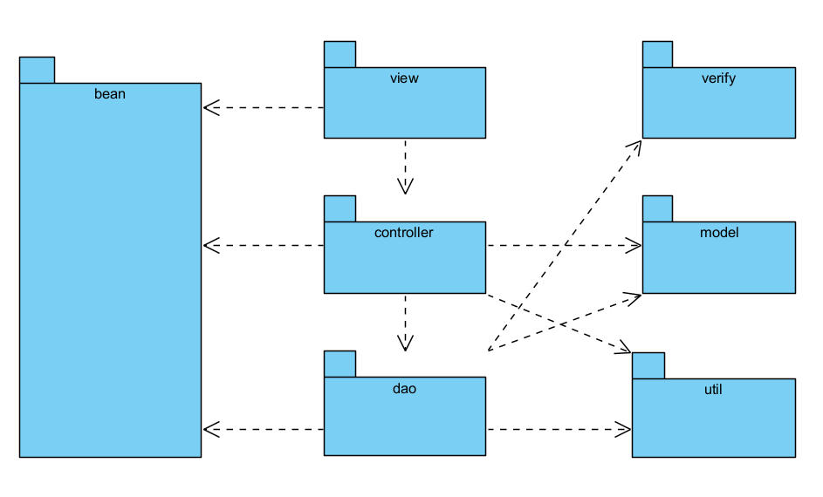

***Package descriptions***

| **No** | **Package** | **Description** |
| --- | --- | --- |
| 01 | Verify | The verify package serves as a dedicated space for verification-related functionalities in the application. It encapsulates the logic required for generating random codes and sending verification emails, promoting code modularity and reusability. By grouping these functionalities within a distinct package, it becomes easier to manage and maintain the verification-related codebase separately. |
| 02 | Util | The util package serves as a repository for reusable utility classes and constants, simplifying development and promoting consistency across the codebase. It enhances code organisation, encapsulation, and maintainability by separating commonly used functionalities and values from the rest of the application's logic. |
| 03 | Model | The model package serves as a container for the application's data models or entities, defining their attributes, relationships, and behaviours. These classes encapsulate the essential data structures and functionality necessary to represent and manipulate core entities within the application. Separating the data models into a dedicated package promotes organisation, modularity, and maintainability of the application's data layer. |
| 04 | Controller  <Controller and Controller.Authentication > | The controller package and its subpackage controller.authentication house the classes responsible for handling user interactions, processing requests, and managing authentication-related functionality. These classes act as the bridge between the UI and the underlying application logic, ensuring smooth communication and facilitating the execution of user-specific actions and operations. |
| 05 | Dao | The DAO package serves as a crucial component in the data layer of the application. It abstracts the interaction with the database, providing methods and interfaces for accessing, manipulating, and persisting data entities. The DAO classes ensure separation of concerns and promote code reusability by centralising database-related operations in a dedicated package. |

## **2. Database Design**

### **2.1 Database Schema**

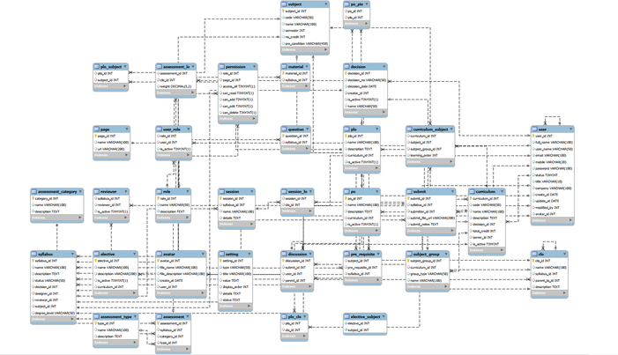

### **2.2 Table Descriptions**

**Permission**

| **No** | **Field name** | **PK?** | **FK?** | **UN?** | **Null?** | **Description** |
| --- | --- | --- | --- | --- | --- | --- |
| *01* | *role_id* |  | *X* |  | *X* | *primary key of the role table describing id of each user* |
| *02* | *page_id* |  | *X* |  | *X* | *primary key of the page table describing id of each page* |
| *03* | *Access_all* |  |  | *X* |  | *accept all or no access* |
| *04* | *can_read* |  |  | *X* |  | *can only read* |
| *05* | *can_add* |  |  | *X* |  | *can only add* |
| *06* | *Can_edit* |  |  | *X* |  | *can only edit* |
| *07* | *Can_delete* |  |  | *X* |  | *can only delete* |

#### **User_role**

| **No** | **Field name** | **PK?** | **FK?** | **UN?** | **Null?** | **Description** |
| --- | --- | --- | --- | --- | --- | --- |
| *01* | *role_id* |  | *X* |  | *X* | *primary key of the role table describing each user* |
| *02* | *use_id* |  | *X* |  | *X* | *primary key of the user table describing each user* |
| *03* | *Is_active* |  |  |  | *X* | *is it working or not* |

#### **Role**

| **No** | **Field name** | **PK?** | **FK?** | **UN?** | **Null?** | **Description** |
| --- | --- | --- | --- | --- | --- | --- |
| *01* | *role_id* | *X* |  | *X* |  | *primary key of the role table describing id each role* |
| *02* | *Name* |  | *X* |  | *X* | *used to store the name of the role.* |
| *03* | *Description* |  |  |  | *X* | *used to store a detailed description of the role.* |

#### **Clo**

| **No** | **Field name** | **PK?** | **FK?** | **UN?** | **Null?** | **Description** |
| --- | --- | --- | --- | --- | --- | --- |
| *01* | *Clo_id* | *X* |  | *X* |  | *A unique identifier for each learning outcome* |
| *02* | *Name* |  |  |  | *X* | *the name of the learning outcome.* |
| *03* | *Syllabus_id* |  | *X* |  | *X* | *the identifier of the syllabus (to be referenced to the syllabus table* |
| *04* | *Parent_lo_id* |  | *X* |  | *X* | *the identifier of the parent learning outcome* |
| *05* | *Description* |  |  |  | *X* | *a detailed description of the learning outcome.* |

#### **Assessment**

| **No** | **Field name** | **PK?** | **FK?** | **UN?** | **Null?** | **Description** |
| --- | --- | --- | --- | --- | --- | --- |
| *01* | *asessment_id* | *X* |  | *X* |  | *primary key of the assessment table describing id each assessment* |
| *02* | *Category_id* |  | *X* |  | *X* | *primary key of the assessment_category table describing id each category* |
| *03* | *Syllabus_id* |  | *X* |  | *X* | *primary key of the syllabus table describing id each syllabus* |
| *04* | *type_id* |  | *X* |  | *X* | *primary key of the assessment_type table describing id each type of assessment* |

#### **Assessment_lo**

| **No** | **Field name** | **PK?** | **FK?** | **UN?** | **Null?** | **Description** |
| --- | --- | --- | --- | --- | --- | --- |
| *01* | *assessment_id* |  | *X* |  | *X* | *primary key of the assessment table describing id each assessment* |
| *02* | *Clo_id* |  | *X* |  | *X* | *primary key of the clo table describing id each clo* |
| *03* | *Weight* |  |  |  | *X* | *the weight of each CLO as a percentage (%) of the total marks for the assessment* |

#### **Session_lo**

| **No** | **Field name** | **PK?** | **FK?** | **UN?** | **Null?** | **Description** |
| --- | --- | --- | --- | --- | --- | --- |
| *01* | *session_id* |  | *X* |  | *X* | *primary key of the session table describing id each session* |
| *02* | *Clo_id* |  | *X* |  | *X* | *primary key of the clo table describing id each clo* |

**Subject**

| **No** | **Field name** | **PK?** | **FK?** | **UN?** | **Null?** | **Description** |
| --- | --- | --- | --- | --- | --- | --- |
| *01* | *subject_id* | *X* |  | *X* |  | *Primary key of the subject table describing of each id subject* |
| *02* | *code* |  |  |  | *X* | *The code of subject* |
| *03* | *name* |  |  |  | *X* | *The name of the subject* |
| *04* | *semester* |  | *X* |  | *X* | *The semester in which the subject is offered* |
| *05* | *no_credit* |  |  |  | *X* | *The number of credits assigned to the subject* |
| *06* | *pre_condition* |  | *X* |  |  | *Pre-requisite conditions for the subject (if any)* |

**Session**

| **No** | **Field name** | **PK?** | **FK?** | **UN?** | **Null?** | **Description** |
| --- | --- | --- | --- | --- | --- | --- |
| *01* | *session_id* | *X* |  | *X* |  | *Unique identifier for each session.* |
| *02* | *syllabus_id* |  | *X* |  | *X* | *Identifier linking to a syllabus table.* |
| *03* | *name* |  |  |  | *X* | *The name of the session* |
| *04* | *details* |  |  |  | *X* | *Additional details or description of the session.* |

**PLO**

| **No** | **Field name** | **PK?** | **FK?** | **UN?** | **Null?** | **Description** |
| --- | --- | --- | --- | --- | --- | --- |
| *01* | *plo_id* | *X* |  | *X* |  | *Unique identifier for each PLO.* |
| *02* | *name* |  |  |  | *X* | *Name of the PLO.* |
| *03* | *description* |  |  |  | *X* | *Description or details of the PLO.* |
| *04* | *curriculum_id* |  | *X* |  | *X* | *Identifier linking to a curriculum table.* |
| *05* | *is_active* |  |  |  | *X* | *Indicates whether the PLO is currently active or not.* |

**elective_subject**

| **No** | **Field name** | **PK?** | **FK?** | **UN?** | **Null?** | **Description** |
| --- | --- | --- | --- | --- | --- | --- |
| *01* | *elective_id* | *X* |  | *X* |  | *Unique identifier for each elective subject.* |
| *02* | *subject_id* |  | *X* |  | *X* | *Identifier linking to a subject table.* |

**User**

| **No** | **Field name** | **PK?** | **FK?** | **UN?** | **Null?** | **Description** |
| --- | --- | --- | --- | --- | --- | --- |
| *01* | *user_id* | *X* |  | *X* |  | *Unique identifier for each user.* |
| *02* | *full_name* |  |  |  | *X* | *Full name of the user.* |
| *03* | *user_name* |  |  | *X* |  | *Username of the user.* |
| *04* | *email* |  |  | *X* | *X* | *Email address of the user.* |
| *05* | *mobile* |  |  |  | *X* | *Mobile number of the user.* |
| *06* | *password* |  | *X* |  | *X* | *Password for the user's account.* |
| *07* | *status* |  |  |  | *X* | *Status of the user's account (e.g., active, inactive).* |
| *08* | *title* |  |  |  | *X* | *Title or job position of the user.* |
| *09* | *company* |  |  |  | *X* | *Name of the user's company.* |
| *10* | *create_at* |  |  |  | *X* | *Timestamp indicating the creation date of the user record.* |
| *11* | *update_at* |  |  |  | *X* | *Timestamp indicating the last update of the user record.* |
| *12* | *modified_by* |  | *X* |  | *X* | *Identifier of the user who last modified the record.* |
| *13* | *avatar_id* |  | *X* |  | *X* | *Identifier linking to an avatar table.*  *In this description, the primary key constraint is applied to the user* |

**pre_requisite**

| **No** | **Field name** | **PK?** | **FK?** | **UN?** | **Null?** | **Description** |
| --- | --- | --- | --- | --- | --- | --- |
| *01* | *subject_id* |  | *X* |  | *X* | *Identifier linking to a subject table.* |
| *02* | *pre_requisite_id* |  | *X* |  | *X* | *Identifier linking to a subject table representing the pre-requisite subject.* |
| *03* | *syllabus_id* |  | *X* |  | *X* | *Identifier linking to a syllabus table.* |

**plo_clo**

| **No** | **Field name** | **PK?** | **FK?** | **UN?** | **Null?** | **Description** |
| --- | --- | --- | --- | --- | --- | --- |
| *01* | *plo_id* |  | *X* |  | *X* | *Identifier linking to a CLO (Course Learning Outcome) table.* |
| *02* | *clo_id* |  | *X* |  | *X* | *Identifier linking to a CLO (Course Learning Outcome) table.* |

**Question**

| **No** | **Field name** | **PK?** | **FK?** | **UN?** | **Null?** | **Description** |
| --- | --- | --- | --- | --- | --- | --- |
| *01* | *question_id* | *X* |  | *X* |  | *Primary key of the role table describing id each question* |
| *02* | *syllabus_id* |  | *X* |  | *X* | *The identifier of the syllabus (to be referenced to the syllabus table)* |

**Elective**

| **No** | **Field name** | **PK?** | **FK?** | **UN?** | **Null?** | **Description** |
| --- | --- | --- | --- | --- | --- | --- |
| *01* | *elective_id* | *X* |  | *X* |  | *Unique identifier for each elective subject* |
| *02* | *name* |  |  |  | *X* | *The name of the elective subject.* |
| *03* | *description* |  |  |  | *X* | *Description of the elective subject.* |
| *04* | *is_active* |  |  |  | *X* | *Indicates if the elective subject is active or not.* |
| *05* | *curriculum_id* |  | *X* |  | *X* | *Foreign key referencing the curriculum the elective is associated with.* |

**Decision**

| **No** | **Field name** | **PK?** | **FK?** | **UN?** | **Null?** | **Description** |
| --- | --- | --- | --- | --- | --- | --- |
| *01* | *decision_id* | *X* |  | *X* |  | *Unique identifier for each decision.* |
| *02* | *decision_no* |  |  |  |  | *The number associated with the decision.* |
| *03* | *decision_date* |  |  |  |  | *The date when the decision was made.* |
| *04* | *creator_id* |  | *X* |  |  | *Foreign key referencing the creator or author of the decision.* |
| *05* | *is_active* |  |  |  | *X* | *Indicates if the decision is currently active or not.* |
| *06* | *name* |  |  |  | *X* | *The name or title associated with the decision.* |

**Curriculum**

| **No** | **Field name** | **PK?** | **FK?** | **UN?** | **Null?** | **Description** |
| --- | --- | --- | --- | --- | --- | --- |
| *01* | *curriculum_id* | *X* |  | *X* |  | *Unique identifier for each curriculum.* |
| *02* | *code* |  |  | *X* |  | *The code or identifier associated with the curriculum.* |
| *03* | *name* |  |  |  |  | *The name of the curriculum.* |
| *04* | *description* |  |  |  | *X* | *Description or additional information about the curriculum.* |
| *05* | *decision* |  | *X* |  |  | *Foreign key referencing the decision associated with the curriculum.* |
| *06* | *total_credit* |  |  |  |  | *The total credit or unit requirement for the curriculum.* |
| *07* | *owner_id* |  | *X* |  |  | *Foreign key referencing the owner or creator of the curriculum.* |
| *08* | *is_active* |  |  |  | *X* | *Indicates if the curriculum is currently active or not.* |

**Syllabus**

| **No** | **Field name** | **PK?** | **FK?** | **UN?** | **Null?** | **Description** |
| --- | --- | --- | --- | --- | --- | --- |
| *01* | *syllabus_id* | *X* |  | *X* |  | *Unique identifier for each syllabus.* |
| *02* | *name* |  |  |  | *X* | *The name or title associated with the syllabus.* |
| *03* | *description* |  |  |  | *X* | *Description or additional information about the syllabus.* |
| *04* | *status* |  |  |  | *X* | *The status of the syllabus (e.g., draft, in review, approved).* |
| *05* | *decision_id* |  | *X* |  | *X* | *Foreign key referencing the decision associated with the syllabus.* |
| *06* | *designer_id* |  | *X* |  | *X* | *Foreign key referencing the designer or creator of the syllabus.* |
| *07* | *reviewer_id* |  | *X* |  | *X* | *Foreign key referencing the reviewer of the syllabus.* |
| *08* | *subject_id* |  | *X* |  |  | *Foreign key referencing the subject associated with the syllabus.* |
| *09* | *degree_level* |  |  |  | *X* | *The degree level to which the syllabus belongs (e.g., undergraduate, graduate).* |

**Discussion**

| **No** | **Field name** | **PK?** | **FK?** | **UN?** | **Null?** | **Description** |
| --- | --- | --- | --- | --- | --- | --- |
| *01* | *discussion_id* | *X* |  | *X* |  | *Unique identifier for each discussion entry.* |
| *02* | *submit_id* |  | *X* |  |  | *Foreign key referencing the submission or topic to which the discussion* |
| *03* | *user_id* |  | *X* |  |  | *Foreign key referencing the user who made the discussion entry.* |
| *04* | *parent_id* |  | *X* |  | *X* | *Foreign key referencing the parent discussion entry, if any, indicating the hierarchical structure of discussions (e.g., replies to a comment).* |

#### 

**submit**

| **No** | **Field name** | **PK?** | **FK?** | **UN?** | **Null?** | **Description** |
| --- | --- | --- | --- | --- | --- | --- |
| *01* | *submit_id* | *X* |  | *X* |  | *Unique identifier for each discussion entry.* |
| *02* | *syllabus_id* |  | *X* |  |  | *Foreign key referencing the syllabus of submit* |
| *03* | *submitter_id* |  | *X* |  |  | *Foreign key referencing the person who made the submission.* |
| *04* | *submit_file_url* |  |  |  | *X* | *Shows the url of the submit* |
| *05* | *submit_notes* |  |  |  | *X* | *Indicates the note of submit* |

**setting**

| **No** | **Field name** | **PK?** | **FK?** | **UN?** | **Null?** | **Description** |
| --- | --- | --- | --- | --- | --- | --- |
| *01* | *setting_id* | *X* |  | *X* |  | *Unique identifier for each discussion entry.* |
| *02* | *type* |  |  |  | *X* | *Indicates the category of the setting* |
| *03* | *title* |  |  |  | *X* | *Indicates the title of the setting* |
| *04* | *value* |  |  |  | *X* | *Indicates the value of the setting* |
| *05* | *display_order* |  |  |  | *X* | *Indicates the display order of the setting* |
| *06* | *details* |  |  |  | *X* | *Indicates the detail of the setting* |
| *07* | *status* |  |  |  | *X* | *Indicates whether the setting is active or not* |

#### 

**assessment_type**

| **No** | **Field name** | **PK?** | **FK?** | **UN?** | **Null?** | **Description** |
| --- | --- | --- | --- | --- | --- | --- |
| *01* | *type_id* | *X* |  |  |  | *Unique identifier for each discussion entry.* |
| *02* | *name* |  |  |  | *X* | *Indicates the name of the assessment type* |
| *03* | *description* |  |  |  | *X* | *Indicates the description of the assessment type* |

#### 

**po_plo**

| **No** | **Field name** | **PK?** | **FK?** | **UN?** | **Null?** | **Description** |
| --- | --- | --- | --- | --- | --- | --- |
| *01* | *po_id* | *X* | *X* |  |  | *Indicates the po mapping to corresponding plo* |
| *02* | *plo_id* | *X* | *X* |  |  | *Indicates the plo mapping to corresponding po* |

#### 

**page**

| **No** | **Field name** | **PK?** | **FK?** | **UN?** | **Null?** | **Description** |
| --- | --- | --- | --- | --- | --- | --- |
| *01* | *page_id* | *X* |  |  |  | *Unique identifier for each discussion entry.* |
| *02* | *name* |  |  |  | *X* | *Indicates the name of web page* |
| *03* | *url* |  |  |  | *X* | *Indicates the url of web page* |

#### 

**plo_subject**

| **No** | **Field name** | **PK?** | **FK?** | **UN?** | **Null?** | **Description** |
| --- | --- | --- | --- | --- | --- | --- |
| *01* | *plo_id* | *X* | *X* |  |  | *Indicates the plo of the subject* |
| *02* | *subject_id* | *X* | *X* |  | *X* | *Indicates subject included in plo* |

#### 

**assessment_category**

| **No** | **Field name** | **PK?** | **FK?** | **UN?** | **Null?** | **Description** |
| --- | --- | --- | --- | --- | --- | --- |
| *01* | *category_id* | *X* |  |  |  | *Unique identifier for each discussion entry.* |
| *02* | *name* |  |  |  | *X* | *Indicates name of category* |
| *03* | *description* |  |  |  | *X* | *Indicates description of category* |

# **II. Code Designs**

**1. Common/User Access/Home Page**

**a. Class Diagram**

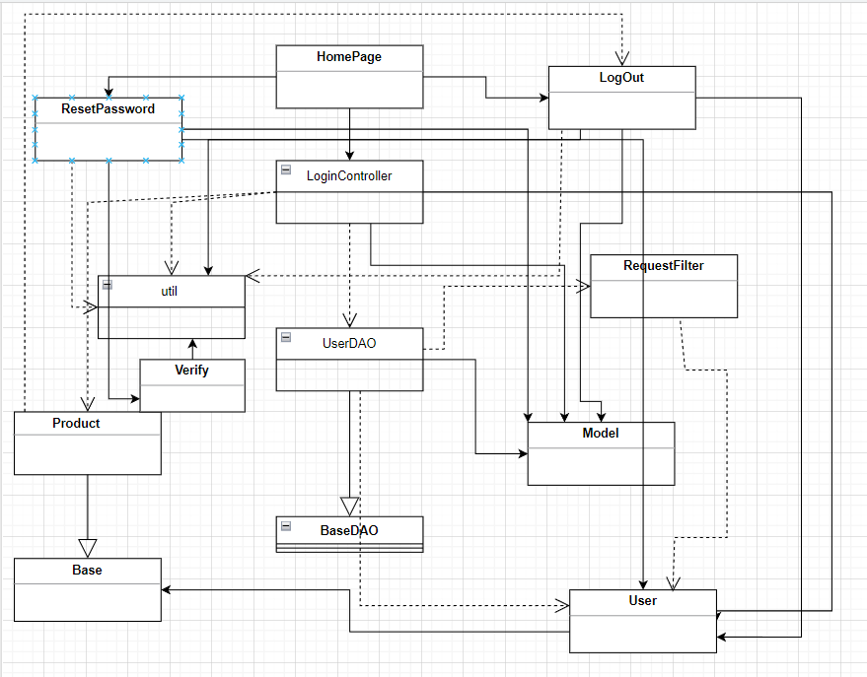

**b. Sequence Diagram**

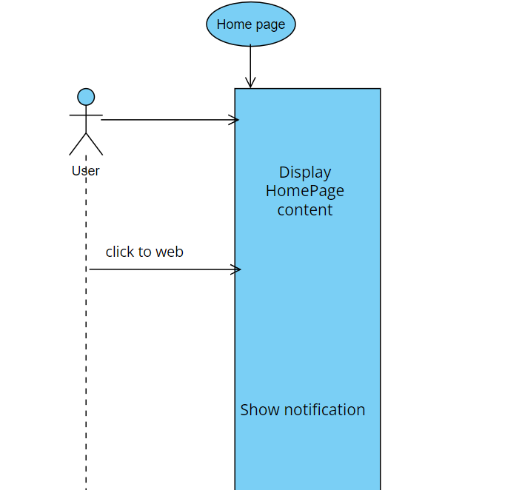

**c. Database Queries**

* INSERT INTO user (`full_name` , `user_name` , `email` , `password`) VALUES (?, ?, ?, ?);
* UPDATE `flmbl5`.`user` SET password = ? WHERE email = ?;
* select * from user where user_name = ? and password = ? or mobile = ? and password = ? or email = ? and password = ?
* select * from user where email = ?
* SELECT sub.name as "subject_name" ,sub.code as "subject_code",pre.subject_id as "subject_id",pre.pre_requisite_id as "pre_id",subpre.code as "pre_code",subpre.name as "pre_name" FROM pre_requisite pre JOIN subject sub ON pre.subject_id = sub.subject_id JOIN subject subpre ON pre.pre_requisite_id = subpre.subject_id where subpre.subject_id =?
* INSERT INTO flmbl5.user (full_name , user_name , email , password,status) VALUES (?, ?, ?, ?, 1)
* UPDATE user SET password = ? WHERE email = ?

## **2. Common/User Access/ User Login**

#### **a. Class Diagram**

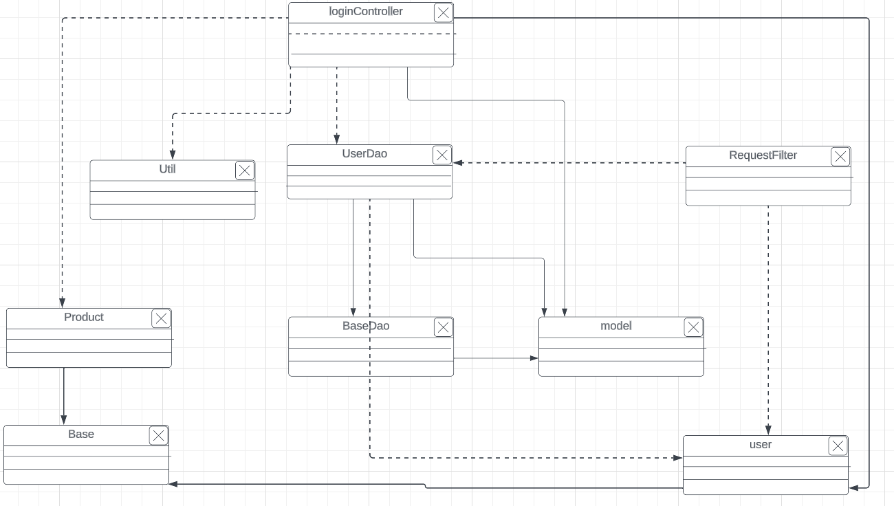

#### **b. Sequence Diagram(s)**

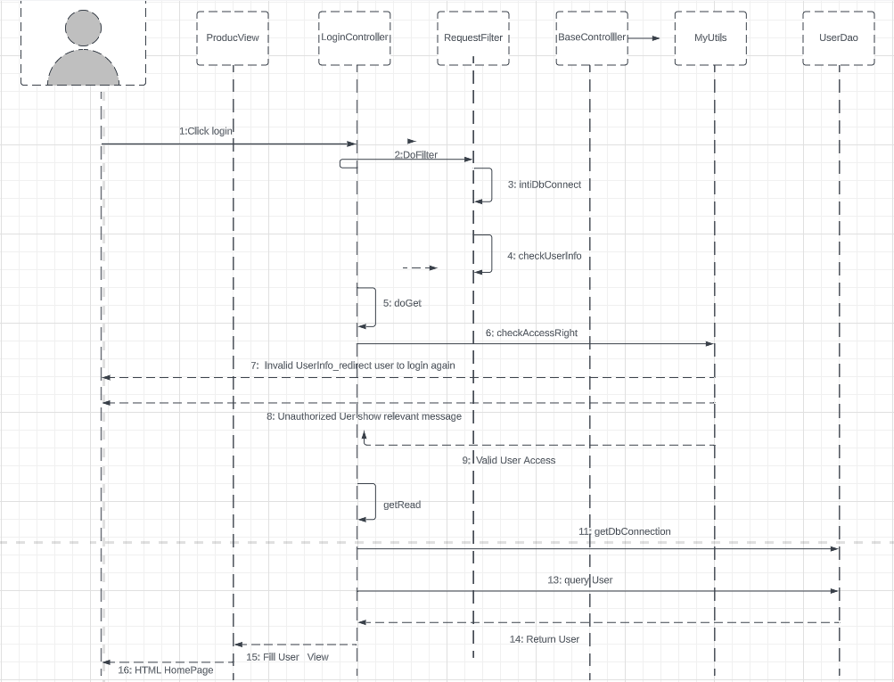

#### **c. Database Queries**

* select * from user where user_name = ? and password = ? or mobile = ? and password = ? or email = ? and password = ?

**3. Common/User Access/User Register**

**a. Class Diagram**

**b. Sequence Diagram**

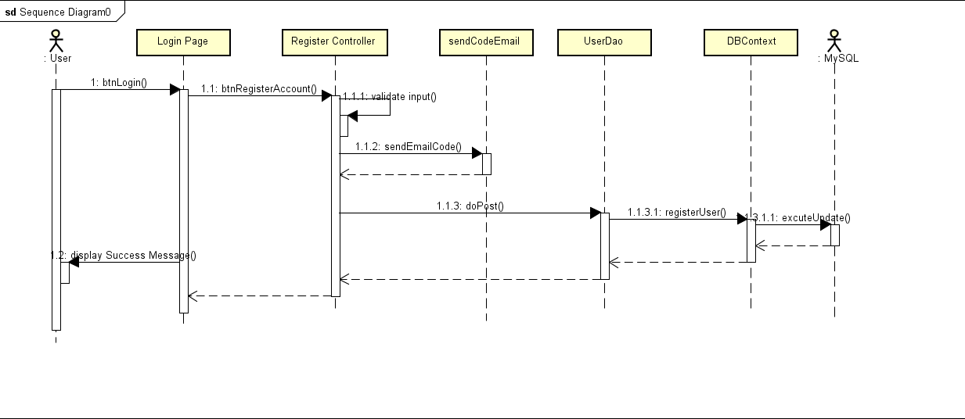

**c. Database Queries**

* INSERT INTO user (`full_name` , `user_name` , `email` , `password`) VALUES (?, ?, ?, ?);
* UPDATE `flmbl5`.`user` SET password = ? WHERE email = ?;
* select * from user where user_name = ? and password = ? or mobile = ? and password = ? or email = ? and password = ?

## **4. Common/User Access/ Reset Password**

#### **a. Class Diagram**

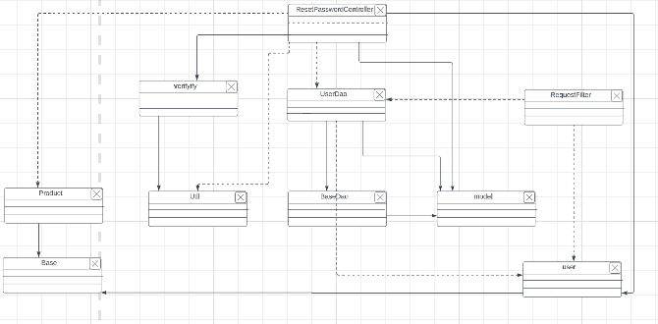

#### **b. Sequence Diagram(s)**

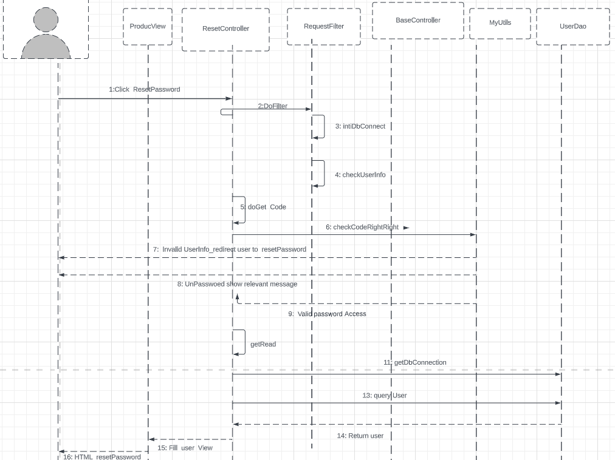

#### **c. Database Queries**

* select * from user where email = ?
* UPDATE g5_flm.user SET password = ? WHERE user_id = ?;
* select * from user where mobile = ?

## **5. Common/User Access/User Profile**

1. **Class Diagram**

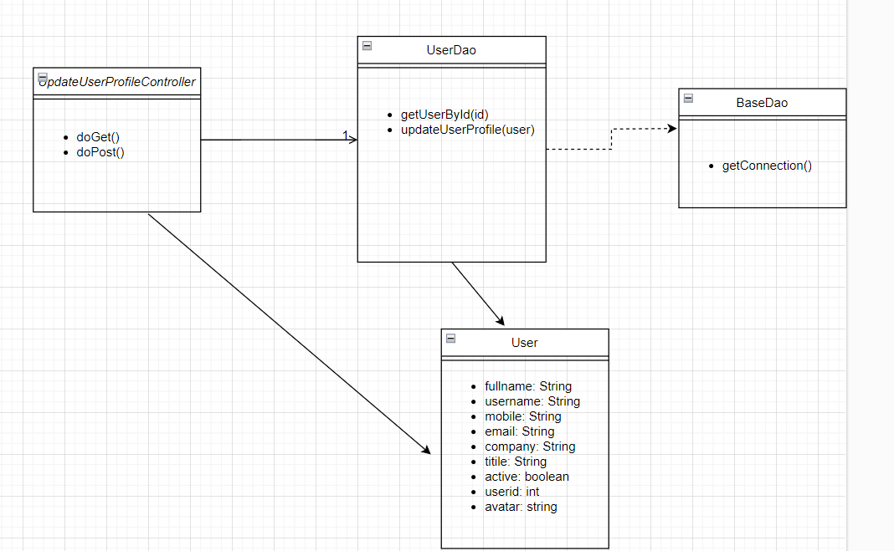

#### **b. Sequence Diagram(s)**

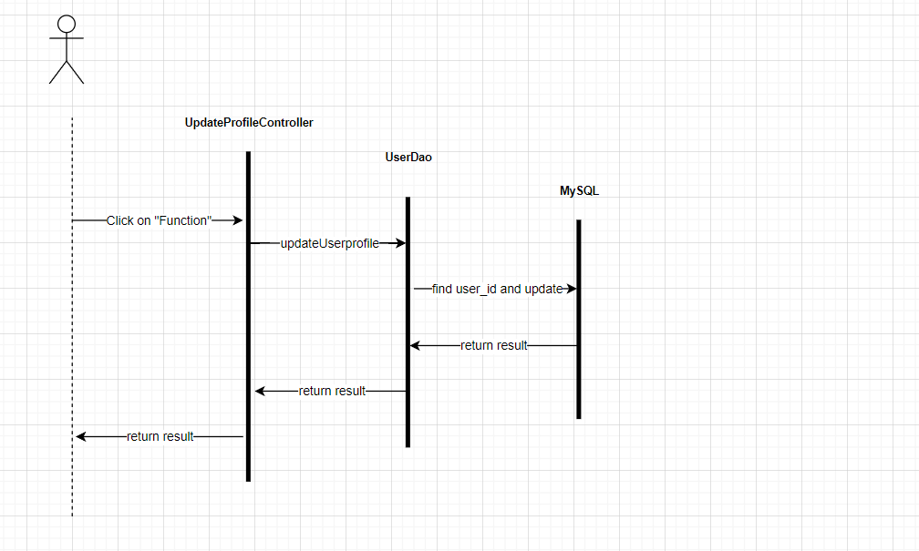

#### **c. Database Queries**

* update user set full_name = ?, user_name = ?, email = ?, mobile = ?, title = ?, company = ? where user_id = ?

## **6. Common/User Access/Change Password**

1. **Class Diagram**

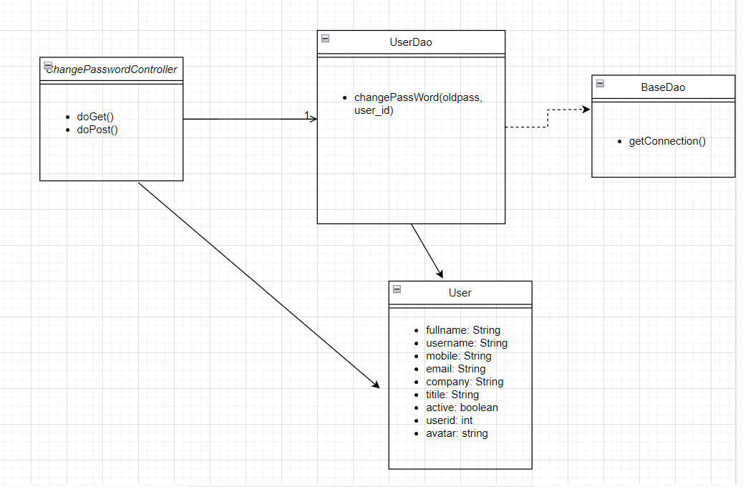

**b. Sequence Diagram**

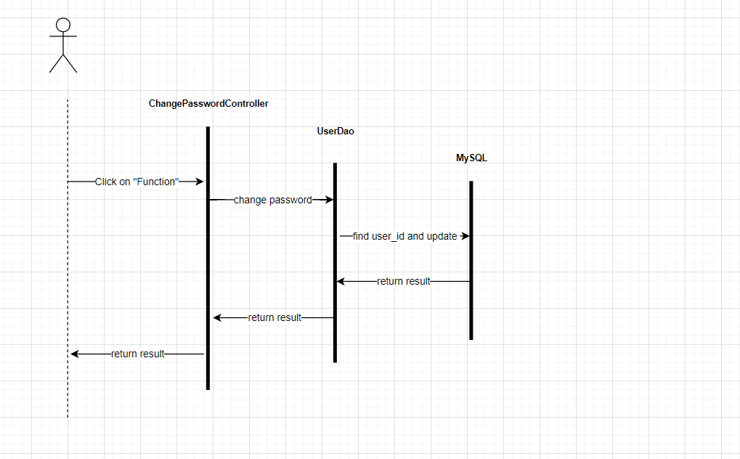

**c. Database Queries**

* update user set password = ? where user_id= ?

## **7. Common/System Admin/Account List**

**a. Class Diagram**

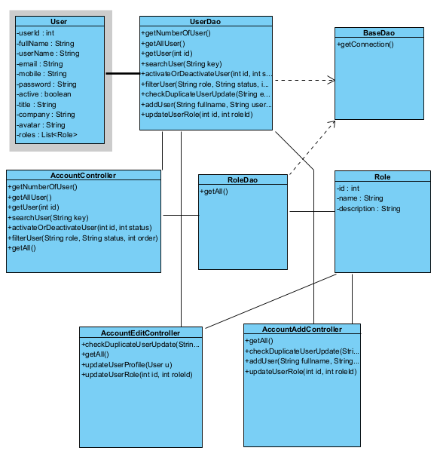

**b. Sequence Diagram**

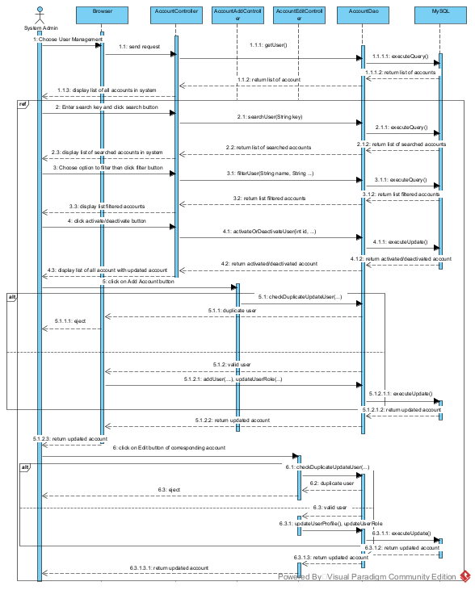

**c. Database Queries**

* select count(*) from user;
* select user.*, file_name from user left join avatar on user.avatar_id = avatar.avatar_id;
* select distinct user.*, file_name from user left join avatar on user.avatar_id = avatar.avatar_id join user_role on user.user_id = user_role.user_id join role on role.role_id = user_role.role_id where name like ? or user_name like ? or full_name like ? or email like ? or mobile like ?
* select distinct user.*, file_name from user left join avatar on user.avatar_id = avatar.avatar_id join user_role on user.user_id = user_role.user_id join role on role.role_id = user_role.role_id where name like ? or user_name like ? or full_name like ? or email like ? or mobile like ? or status = ?
* select distinct user.*, file_name from user left join avatar on user.avatar_id = avatar.avatar_id join user_role on user.user_id = user_role.user_id where role_id = ? and status = ? order by user_id
* update user set status = ? where user_id = ?
* INSERT INTO user (full_name , user_name , email , password, mobile, title, company) VALUES (?, ?, ?, ?, ?, ?, ?)
* insert into user_role values (?, ?, 1);
* SELECT * FROM role
* select r.role_id, r.name, r.description from user_role u JOIN role r ON u.role_id = r.role_id where u.user_id = ? and u.is_active = true
* select * from user where email = ? and user_id != ?
* update user set full_name = ?, user_name = ?, email = ?, mobile = ?, title = ?, company = ? where user_id = ?
* delete from user_role where user_id = ?;
* insert into user_role values (?, ?, 1);

## **8. Common/System Admin/Account Details**

**a. Class Diagram**

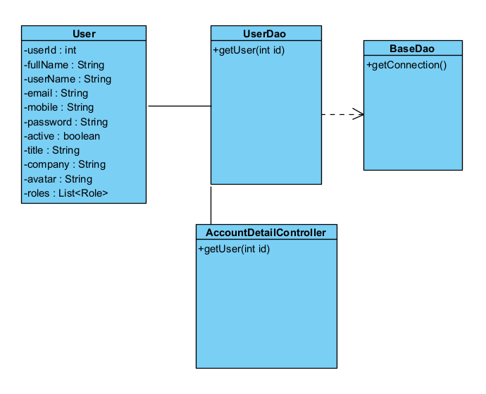

**b. Sequence Diagram**

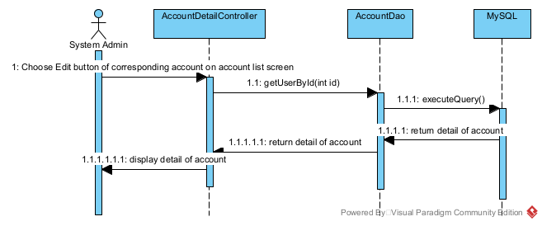

**c. Database Queries**

* select * from user where user_id = ?

## **9. Common/System Admin/Setting List**

#### **a. Class Diagram**

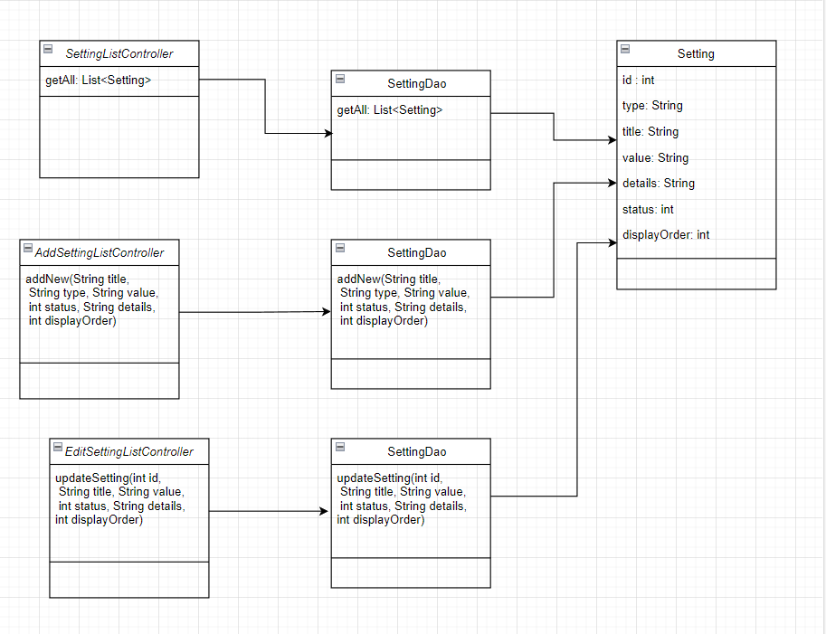

#### **b. Sequence Diagram(s)**

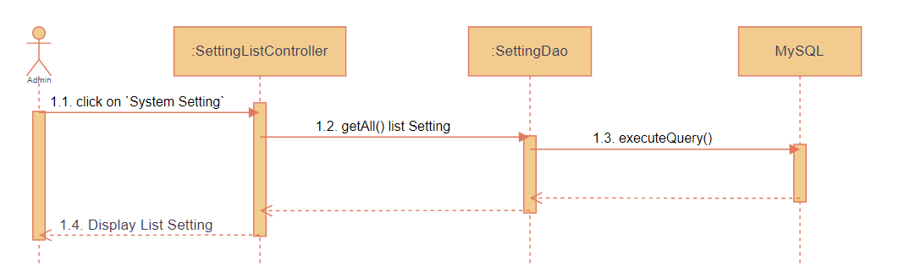

**Add**

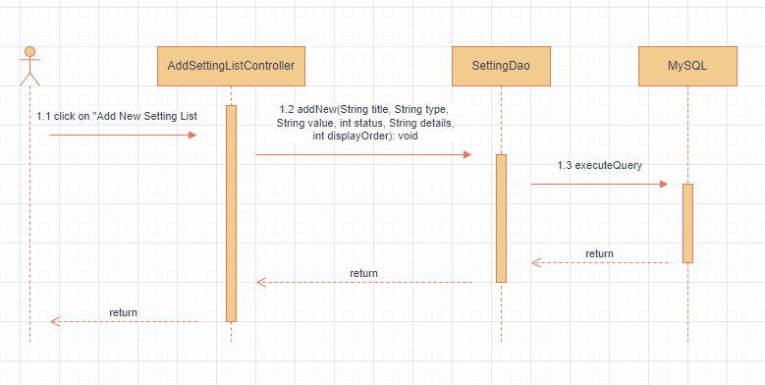

**Edit**

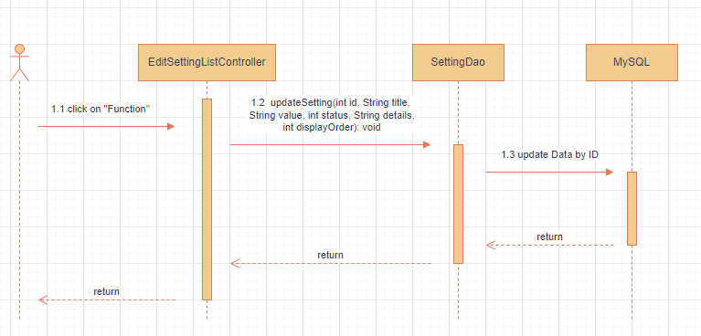

#### **c. Database Queries**

* select * from setting where title LIKE '%" + title + "%'
* INSERT INTO `setting`(`type`, `title`, `value`, `details`, `status` , `display_order`) VALUES (?, ?, ?, ?, ?, ?)
* UPDATE `setting` SET title = ? , value = ?, status = ? , details = ? , type = ? , display_order = ? WHERE setting_id = ?

## **10. Common/System Admin/Setting Details**

#### **a. Class Diagram**

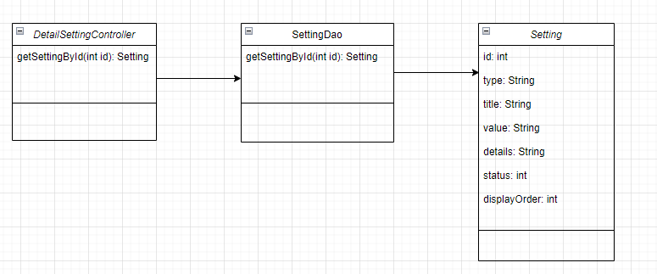

#### **b. Sequence Diagram(s)**

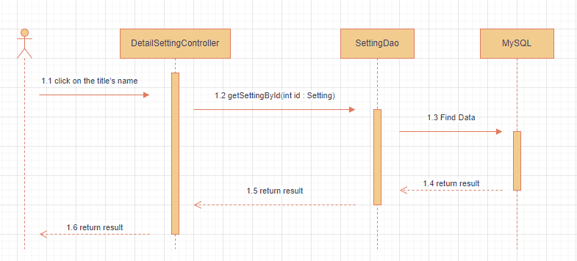

#### **c. Database Queries**

* select * from setting where setting_id = ?

## **11. Curriculums & Subjects/ Curriculum Management/Curriculum List**

**a. Class Diagram**

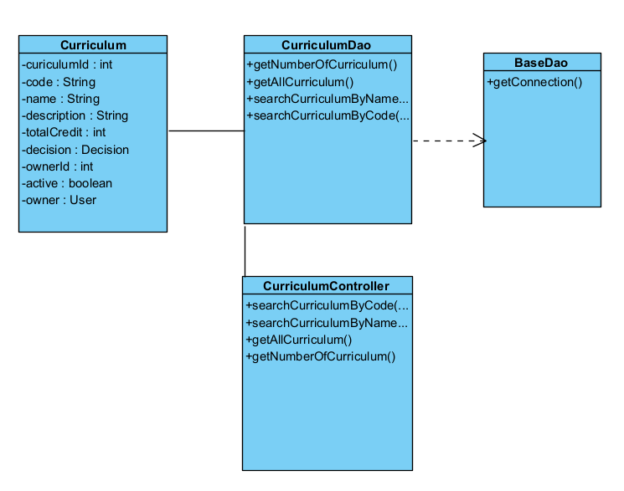

**b. Sequence Diagram**

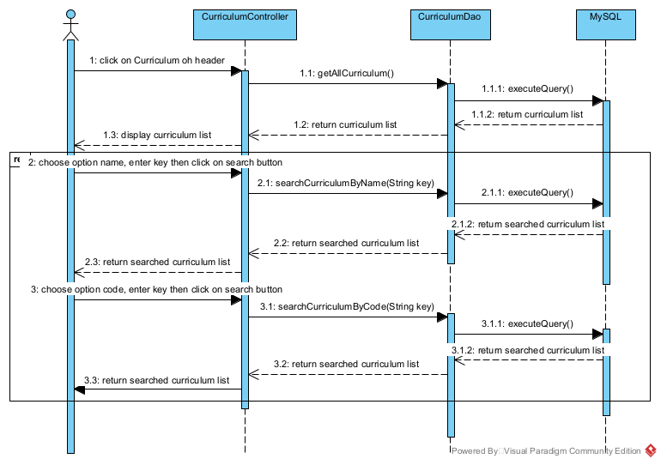

**c. Database Queries**

* select count(*) from curriculum;
* select curriculum.*, decision_no, decision_date from curriculum left join decision on curriculum.decision_id = decision.decision_id where code like ?
* select curriculum.*, decision_no, decision_date from curriculum left join decision on curriculum.decision_id = decision.decision_id where curriculum.name like ?

## **12. Curriculum & Subjects/ Curriculum Management/ New Curriculum**

#### **a. Class Diagram**

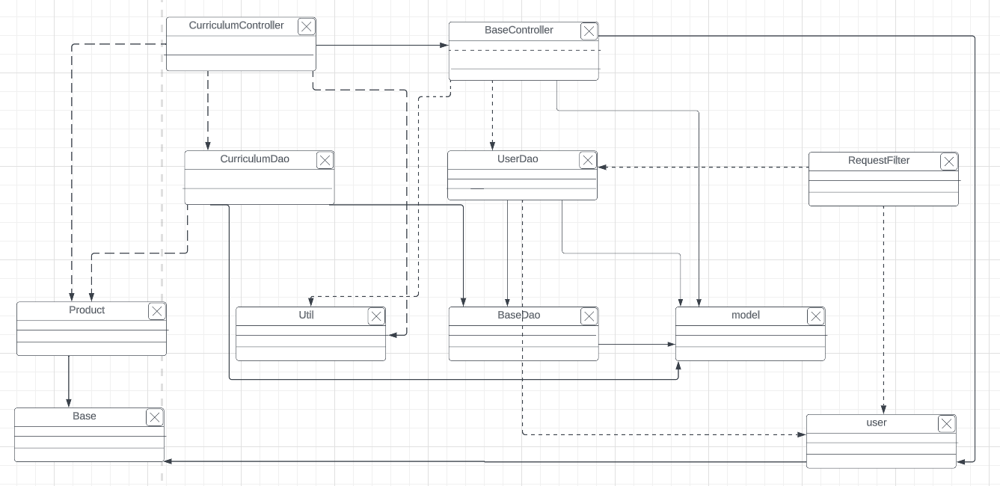

#### **b. Sequence Diagram(s)**

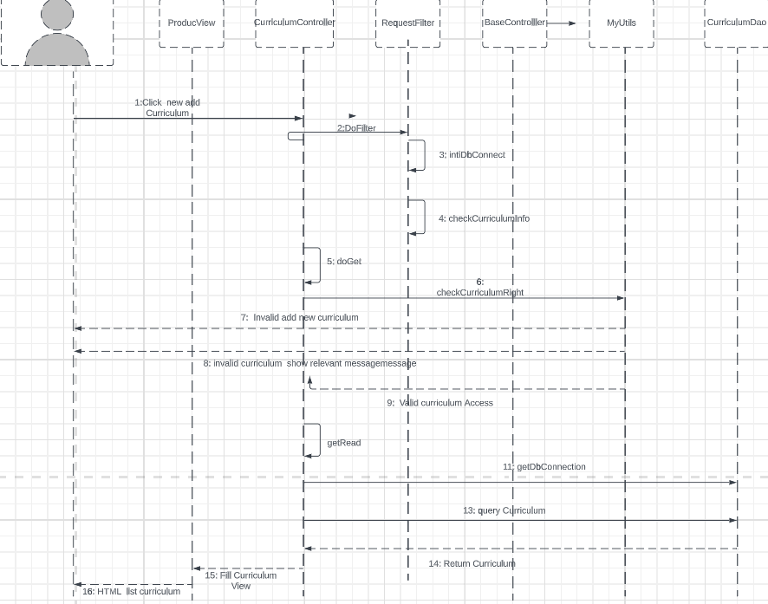

#### **c. Database Queries**

* SELECT curriculum_id FROM g5_flm.curriculum ORDER BY curriculum_id DESC LIMIT 1";
* INSERT INTO `g5_flm`.`curriculum` (`curriculum_id`, `code`, `name`, `description`, `decision_id`, `total_credit`, `is_active`) + "VALUES (?, ?, ?, ?, ?, ?, ?);

## **13. Curriculum & Subjects/ Curriculum Management/Curriculum Edit**

**a. Class Diagram**

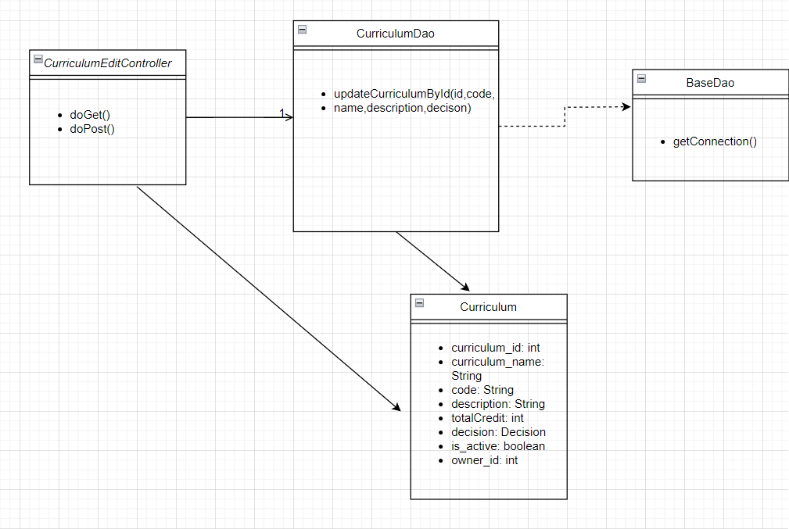

**b. Sequence Diagram**

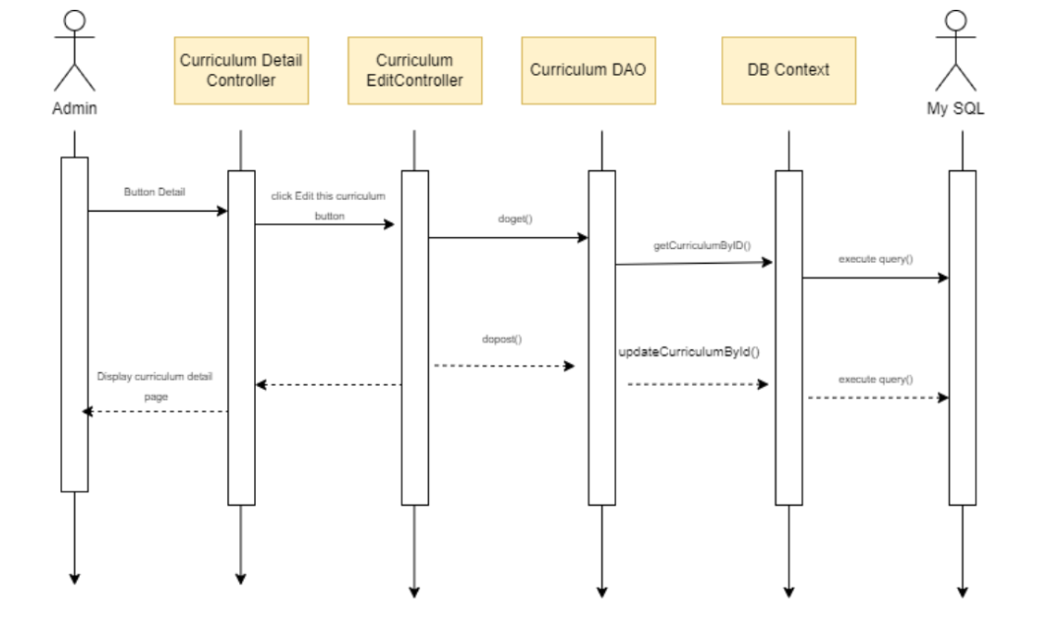

**c. Database Queries**

* update Curriculum c INNER JOIN Decision d ON c.decision_id = d.decision_id set c.code = ?, c.name = ?, c.description = ?, d.decision_no = ? where curriculum_id = ?

## **14. Curriculum & Subjects/ Curriculum Management/Curriculum Overview**

**a. Class Diagram**

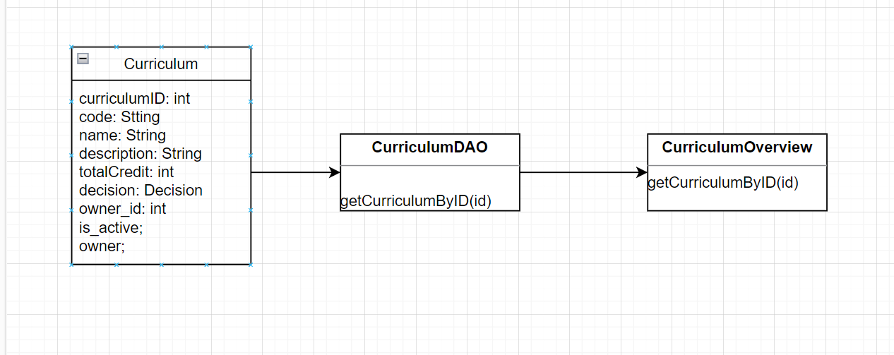

**b. Sequence Diagram**

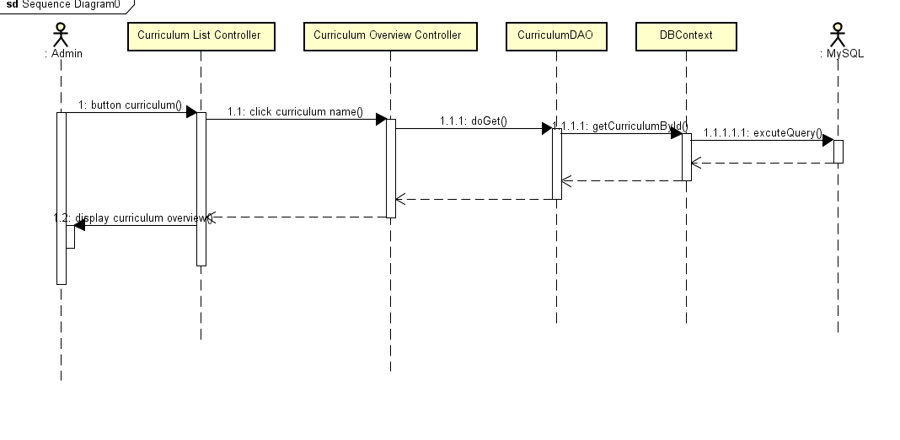

**c. Database Queries**

* SELECT * FROM Curriculum c INNER JOIN Decision d ON c.decision_id = d.decision_id WHERE code like ? or name like ?

## **15. Curriculums & Subjects/ Subject Management/Subject List**

#### **a. Class Diagram**

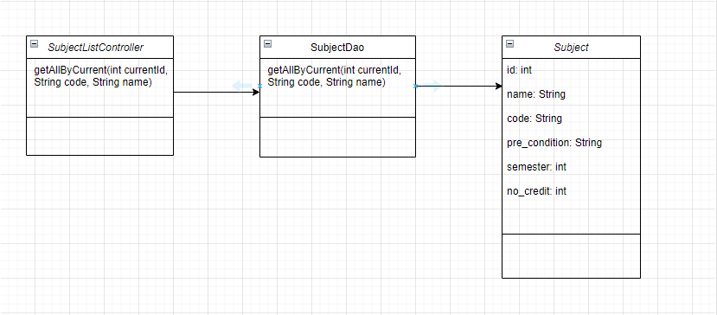

#### **b. Sequence Diagram(s)**

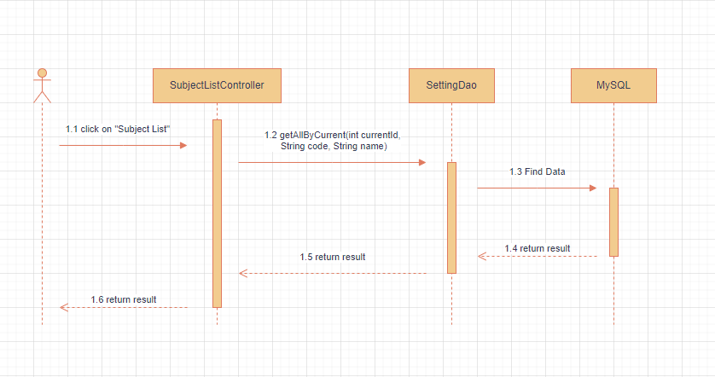

#### **c. Database Queries**

* SELECT sub.subject_id, sub.code, sub.name, sub.semester, sub.no_credit , sub.pre_condition FROM subject sub JOIN curriculum_subject cuSub ON sub.subject_id = cuSub.subject_id WHERE cuSub.curriculum_id = ? AND sub.code LIKE ? AND sub.name LIKE ?

## **16. Curriculums & Subjects/ Subject Management/New Subject**

### a. Class Diagram

### b. Sequence Diagram

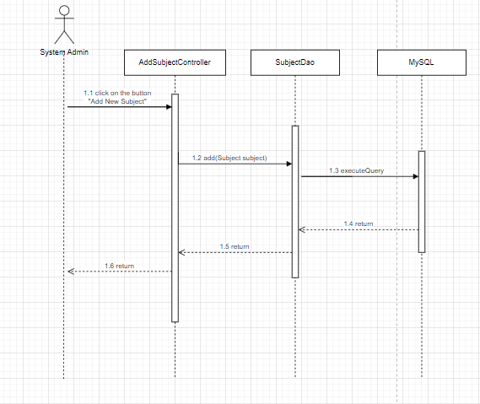

### c. Database Queries

* SELECT * FROM subject where code = ?
* INSERT INTO subject ( code, name, semester, no_credit, pre_condition) VALUES ( ?, ?, ?, ? , ?);

## 17. Curriculums & Subjects/ Subject Management/New Curriculum Subject

### a. Class Diagram

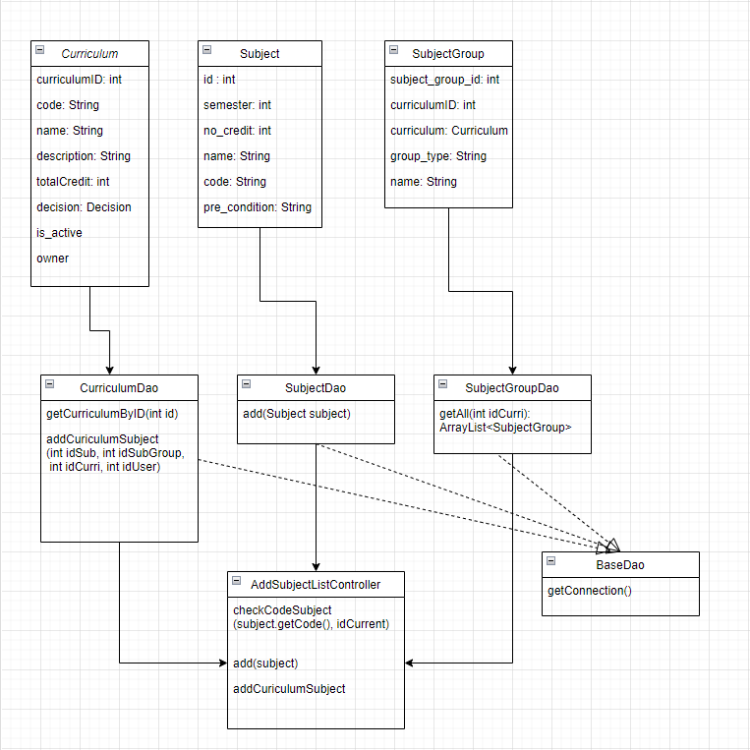

### b. Sequence Diagram

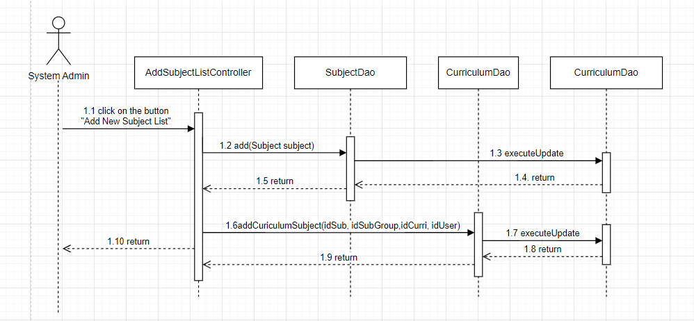

### c. Database Queries

* SELECT * FROM Curriculum c INNER JOIN Decision d ON c.decision_id = d.decision_id where curriculum_id = ?
* SELECT * FROM subject_group where curriculum_id = ?
* INSERT INTO `curriculum_subject` (`curriculum_id`, `subject_id`, `subject_group_id`, `learning_order`) VALUES ( ? , ? , ? , ? );
* INSERT INTO subject ( code, name, semester, no_credit, pre_condition) VALUES ( ?, ?, ?, ? , ?);

## 18. Curriculums & Subjects/ Subject Management/Subject Import

a. Class Diagram

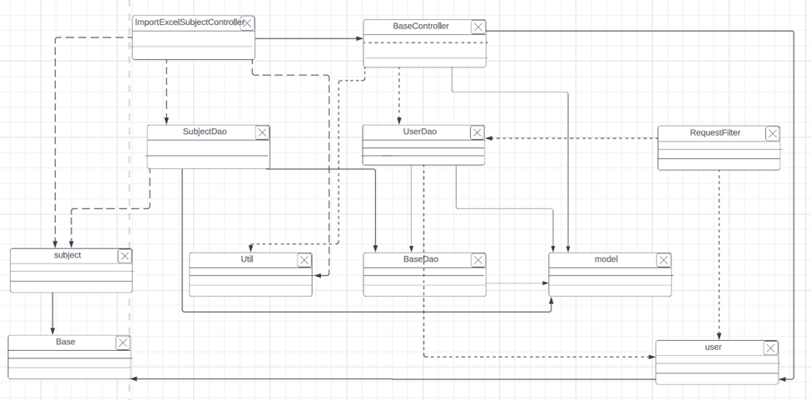

b. Sequence Diagram

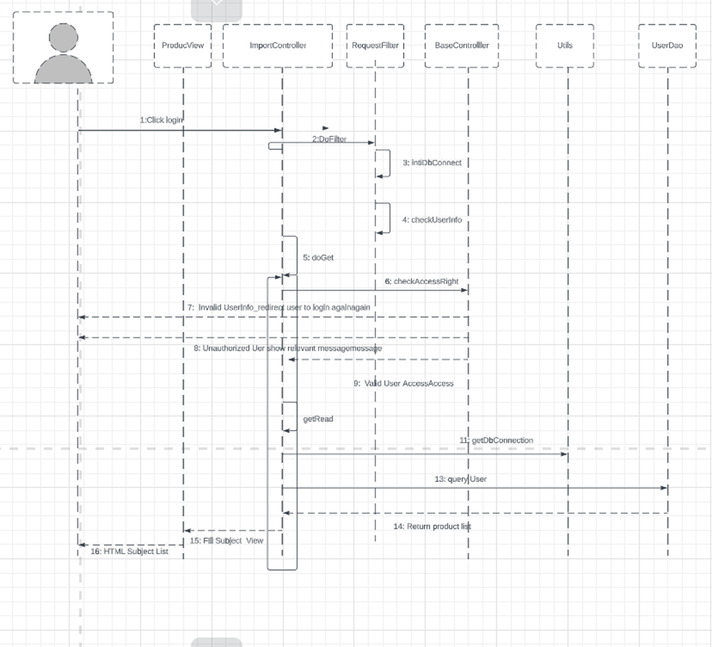

c. Database Queries

INSERT INTO `g5_flm`.`subject` (`subject_id`, `code`, `name`, `semester`, `no_credit`, `pre_condition`) VALUES (?, ?, ?, ?, ?, ?)

## **19. Curriculums & Subjects/ Subject Management/Subject-PLO Mapping**

### a. Class Diagram

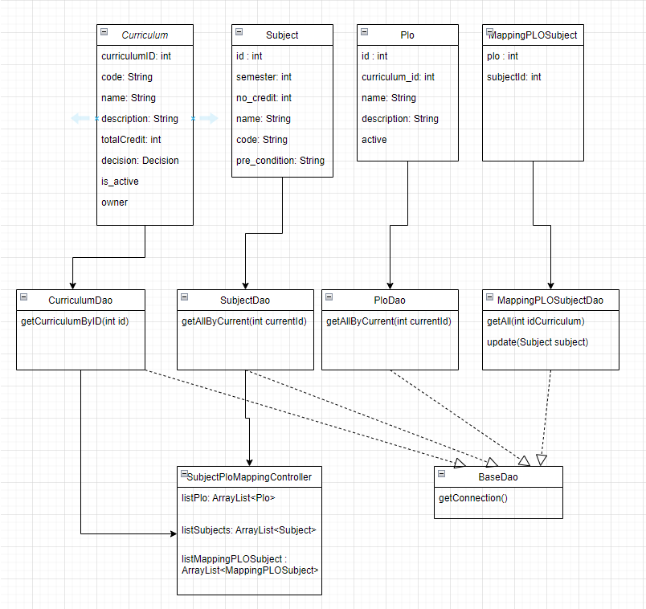

### b. Sequence Diagram

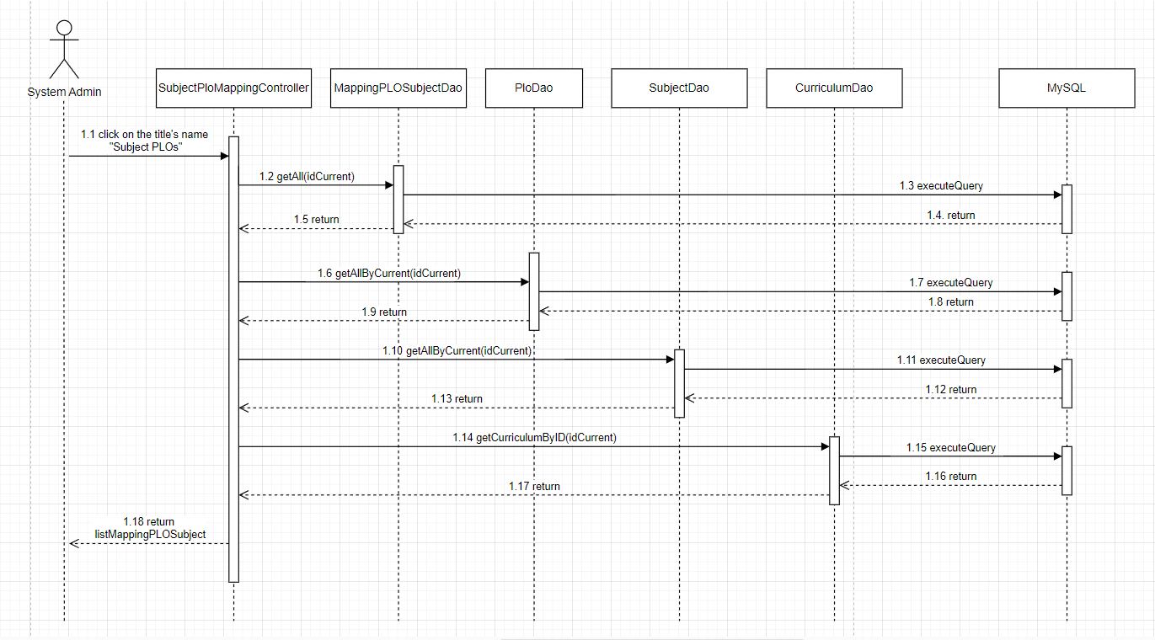

### c. Database Queries

* SELECT * FROM plo where curriculum_id = ?
* SELECT sub.subject_id, sub.code, sub.name, sub.semester, sub.no_credit , sub.pre_condition FROM subject sub JOIN curriculum_subject cuSub ON sub.subject_id = cuSub.subject_id WHERE cuSub.curriculum_id = ?
* SELECT cs.subject_id, ps.plo_id FROM plo_subject ps JOIN curriculum_subject cs ON ps.subject_id = cs.subject_id WHERE cs.curriculum_id = ?
* SELECT * FROM Curriculum c INNER JOIN Decision d ON c.decision_id = d.decision_id where curriculum_id = ?

## 20. Curriculums & Subjects/ Subject Management/Curriculum Subject Details

### a. Class Diagram

### b. Sequence Diagram

**Details** 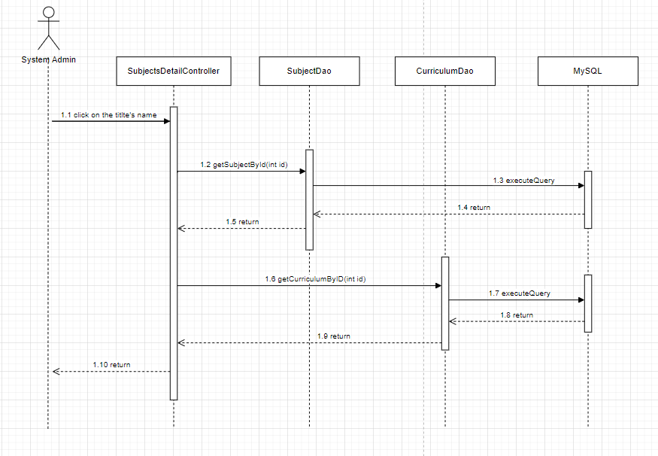

**Edit**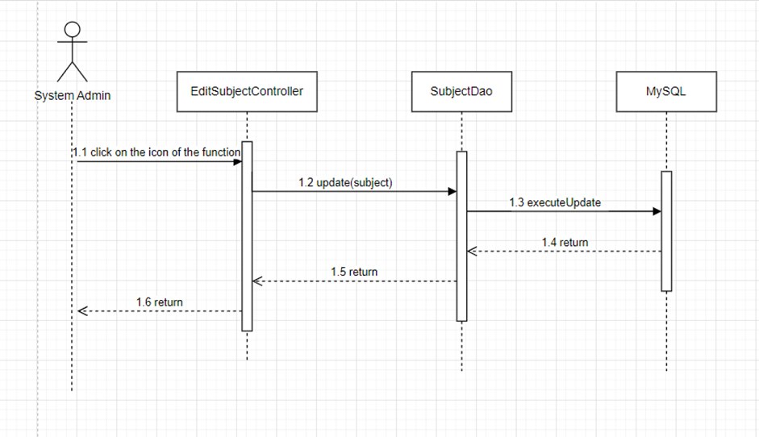

### c. Database Queries

* SELECT * FROM Curriculum c INNER JOIN Decision d ON c.decision_id = d.decision_id where curriculum_id = ?
* SELECT sub.subject_id, sub.code, sub.name, sub.semester, sub.no_credit, sub.pre_condition FROM subject sub where sub.subject_id = ?
* UPDATE `subject` SET `code` = ?, `name` = ?, `semester` = ?, `no_credit` = ?, `pre_condition` = ? WHERE `subject_id` = ?

## **21. Curriculums & Subjects/ Subject Management/Subject Details**

### a. Class Diagram

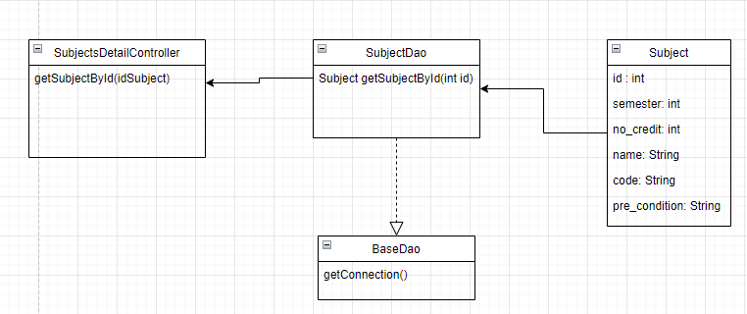

### b. Sequence Diagram

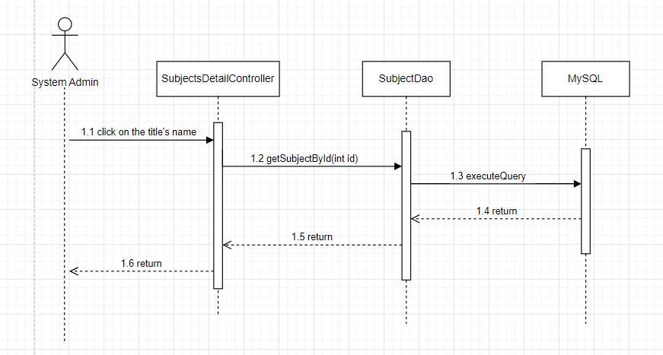

### c. Database Queries

* SELECT sub.subject_id, sub.code, sub.name, sub.semester, sub.no_credit, sub.pre_condition FROM subject sub where sub.subject_id = ?

## **22. Curriculums & Subjects/Curriculum Subjects/Subject Predecessors**

a. Class Diagram

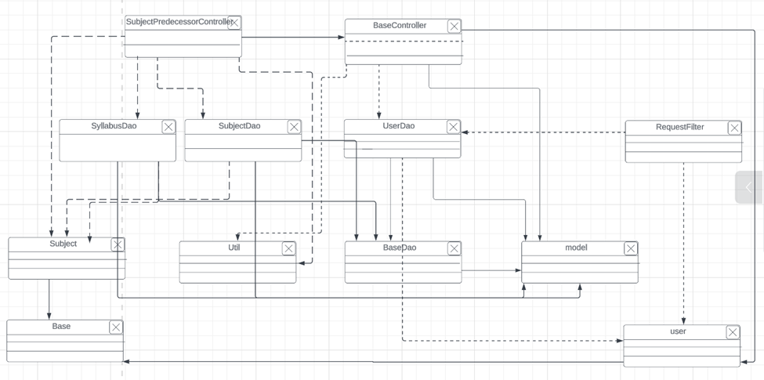

b. Sequence Diagram

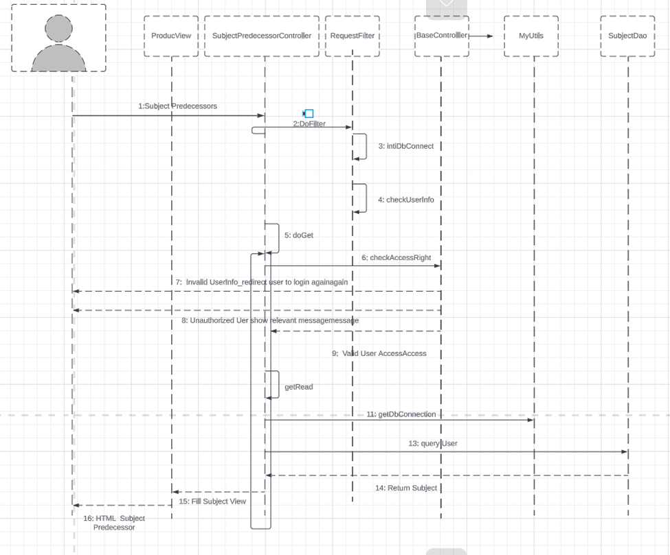

c. Database Queries

* SELECT `subject`.`subject_id`, `subject`.`code`, `subject`.`name`, `subject`.`semester`,`subject`.`no_credit`, `subject`.`pre_condition` FROM `g5_flm`.`subject` WHERE `subject`.`code` LIKE ? OR `subject`.`subject_id` = ?
* SELECT s.subject_id,p.pre_requisite_id, (SELECT s2.code FROM g5_flm.subject s2 WHERE s2.subject_id = p.pre_requisite_id) AS code FROM g5_flm.subject s JOIN g5_flm.pre_requisite p ON p.subject_id = s.subject_id WHERE 1=1; and s.subject_id = ? or s.code like ?
* SELECT g5_flm.syllabus.syllabus_id,g5_flm.subject.code,g5_flm.subject.subject_id, g5_flm.subject.name , g5_flm.syllabus.name, g5_flm.decision.decision_no, g5_flm.decision.decision_date From g5_flm.syllabus join g5_flm.decision on g5_flm.syllabus.decision_id = g5_flm.decision.decision_id join g5_flm.subject on g5_flm.syllabus.subject_id = g5_flm.subject.subject_id WHERE 1=1;and g5_flm.subject.subject_id = ? OR g5_flm.subject.code like ?

## **23. Curriculums & Subjects/Curriculum Subjects/Subject Successors**

a. Class Diagram

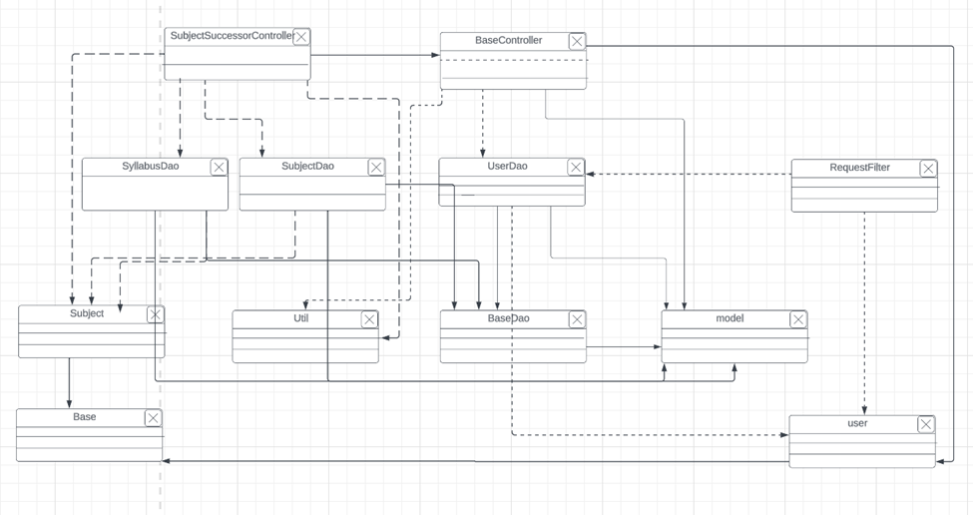

b. Sequence Diagram

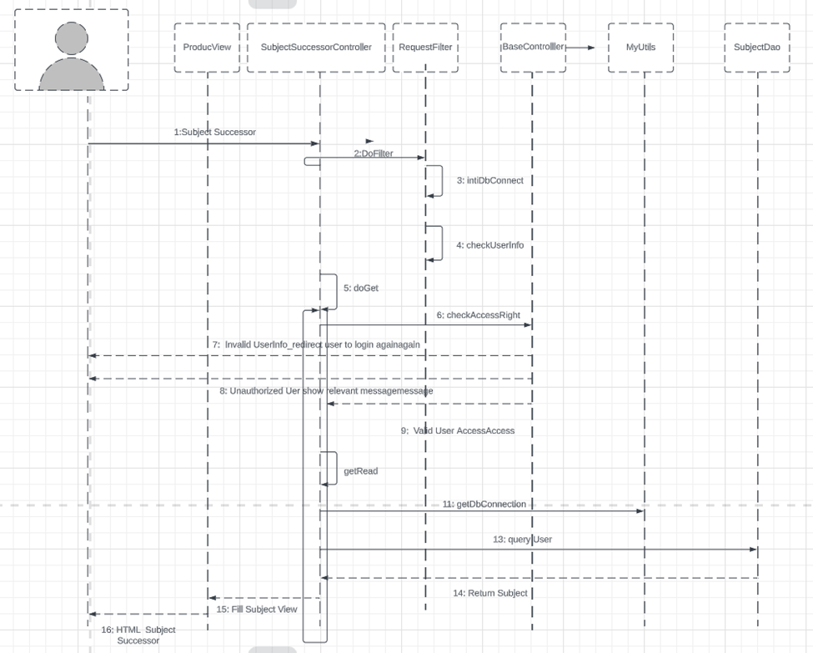

c. Database Queries

- SELECT `subject`.`subject_id`,

`subject`.`code`,

`subject`.`name`,

`subject`.`semester`,

`subject`.`no_credit`,

`subject`.`pre_condition`

FROM `g5_flm`.`subject` WHERE `subject`.`code` LIKE ? OR `subject`.`subject_id` = ?

- SELECT

s.subject_id,

p.pre_requisite_id,

(SELECT s2.code FROM g5_flm.subject s2 WHERE s2.subject_id = p.subject_id) AS cod

FROM

g5_flm.subject s

JOIN g5_flm.pre_requisite p ON p.subject_id = s.subject_id

WHERE 1=1;

and p.pre_requisite_id = ? OR p.pre_requisite_id=(SELECT subject_id FROM g5_flm.subject WHERE code like ?)

* SELECT g5_flm.syllabus.syllabus_id,g5_flm.subject.code,g5_flm.subject.subject_id, g5_flm.subject.name , g5_flm.syllabus.name, g5_flm.decision.decision_no,

g5_flm.decision.decision_date From g5_flm.syllabus

join g5_flm.decision on g5_flm.syllabus.decision_id = g5_flm.decision.decision_id

join g5_flm.subject on g5_flm.syllabus.subject_id = g5_flm.subject.subject_id

WHERE 1=1\n"

and g5_flm.subject.subject_id = ? or g5_flm.subject.code like ?

## 24. Curriculums Details/PO Management/PO List

a. Class Diagram

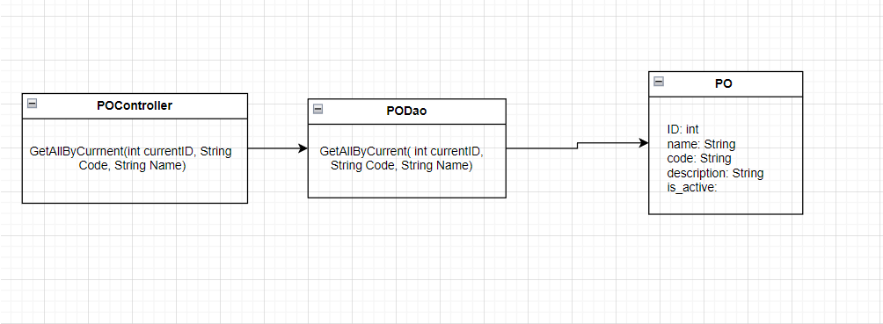

b. Sequence Diagram

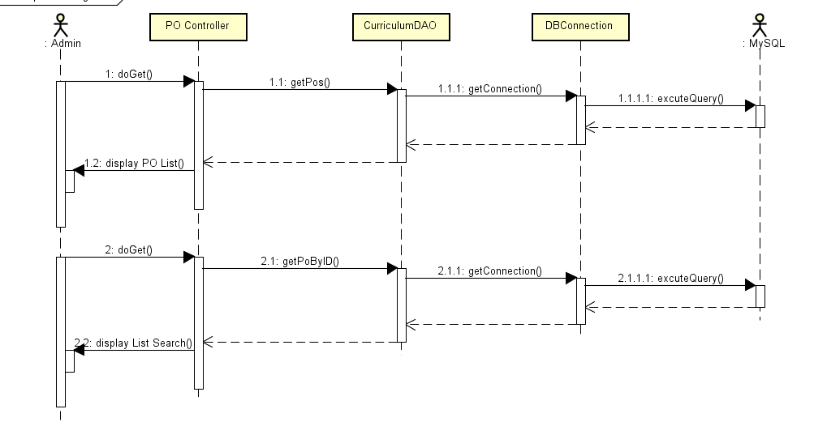

c. Database Queries

* SELECT p.po_id, p.name, p.curriculum_id, p.description, p.is_active FROM po p JOIN curriculum c ON c.curriculum_id = p.curriculum_id WHERE p.curriculum_id = ? AND p.name LIKE ?

**25. Curriculums Details/PO Management/PO Details**

a. Class Diagram

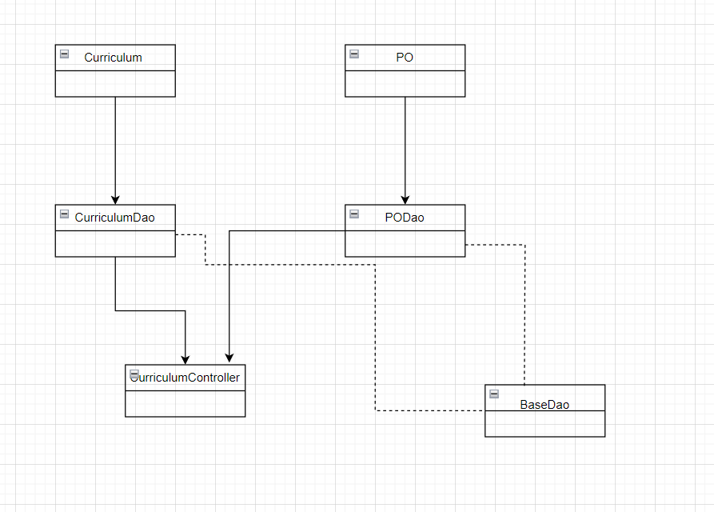

b. Sequence Diagram

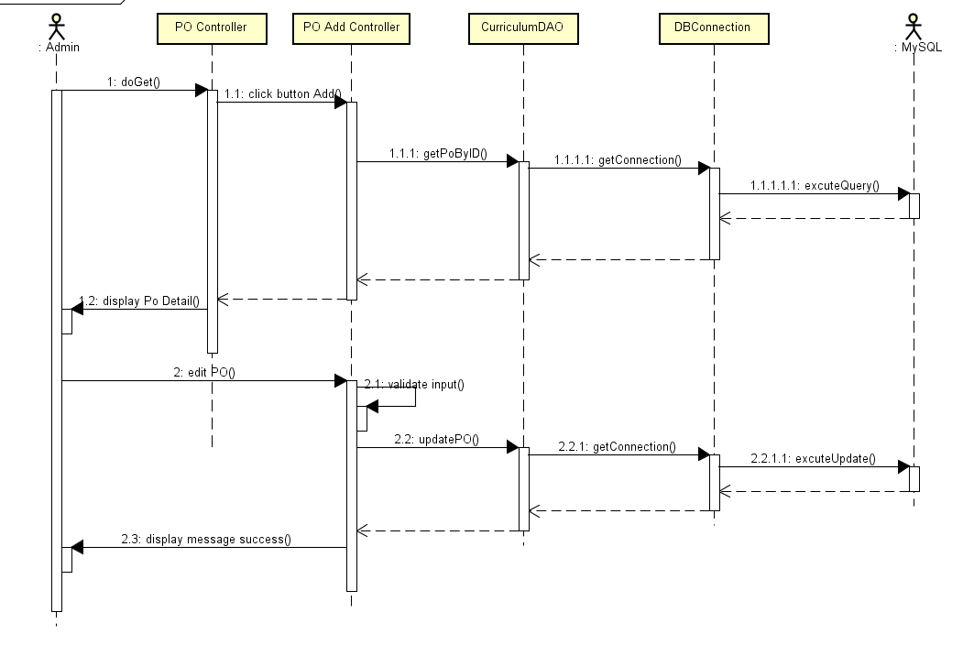

c. Database Queries

* SELECT * FROM po p INNER JOIN curriculum ON p.curriculum_id = c.curriculum_id where curriculum_id = ?
* SELECT sub.po_id, sub.name, sub.description, sub.curriculum_id, sub.is_active FROM po sub where sub.po_id = ?
* UPDATE `po` SET `id` = ?, `name` = ?, `curriculum_id` = ?, `description` = ?, `is_active` = ? WHERE `subject_id` = ?

**26. Curriculums Details/PO Management/PO Import**

a. Class Diagram

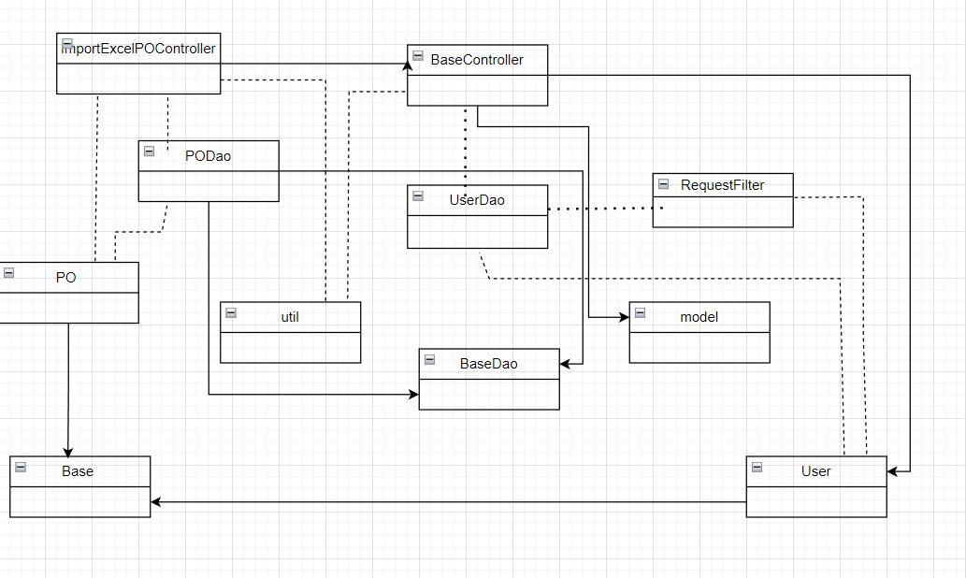

b. Sequence Diagram

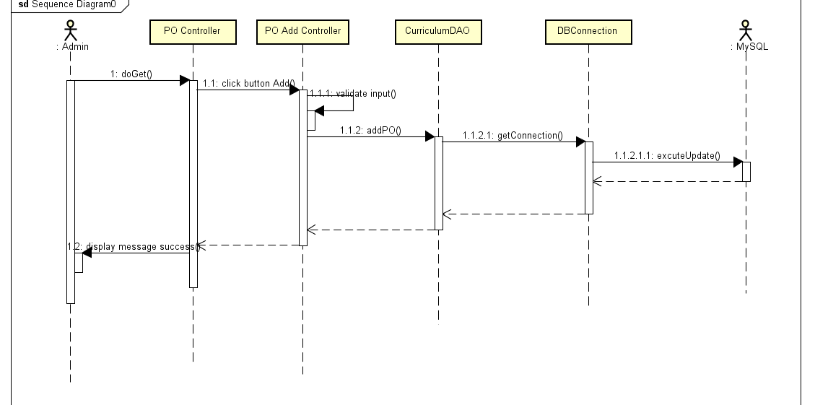

c. Database Queries

INSERT INTO `g5_flm`.`po` (po_id, name, description, curriculum_id, is_active) VALUES (?, ?, ?, ?, ?)

**27. Curriculums Details/PLO Management/PLO List**

a. Class Diagram

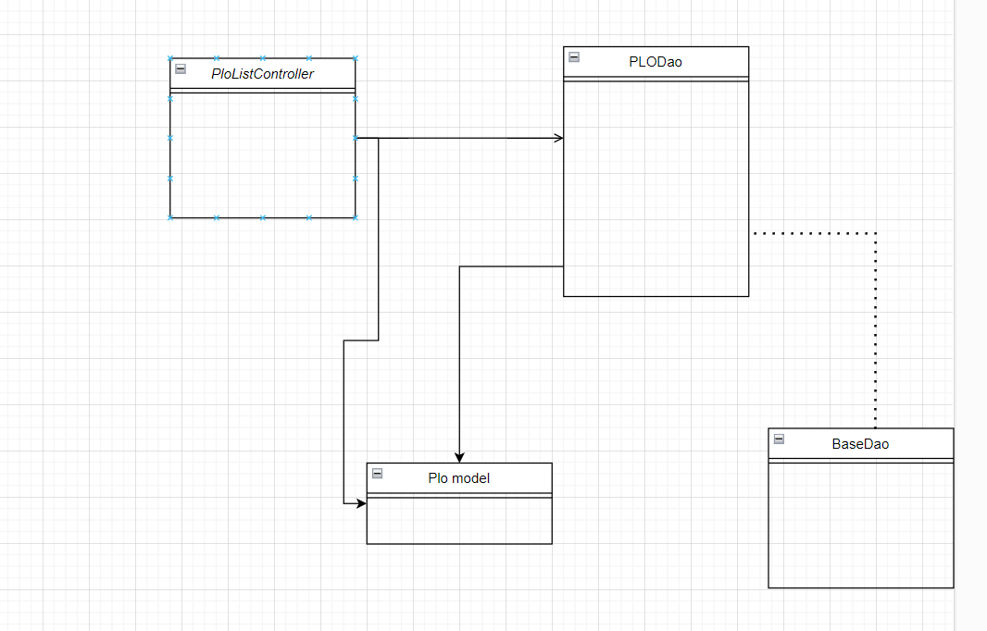

b. Sequence Diagram

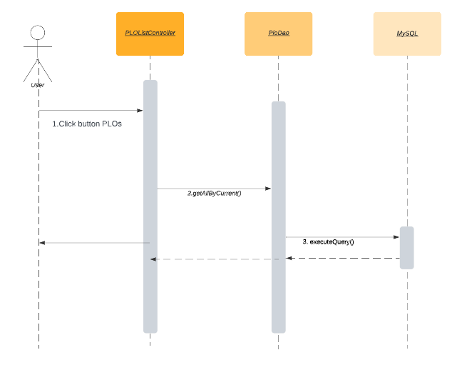

c. Database Queries

SELECT * FROM plo where curriculum_id = ? AND name like ?

28. Curriculums Details/PLO Management/PLO Details

a. Class Diagram

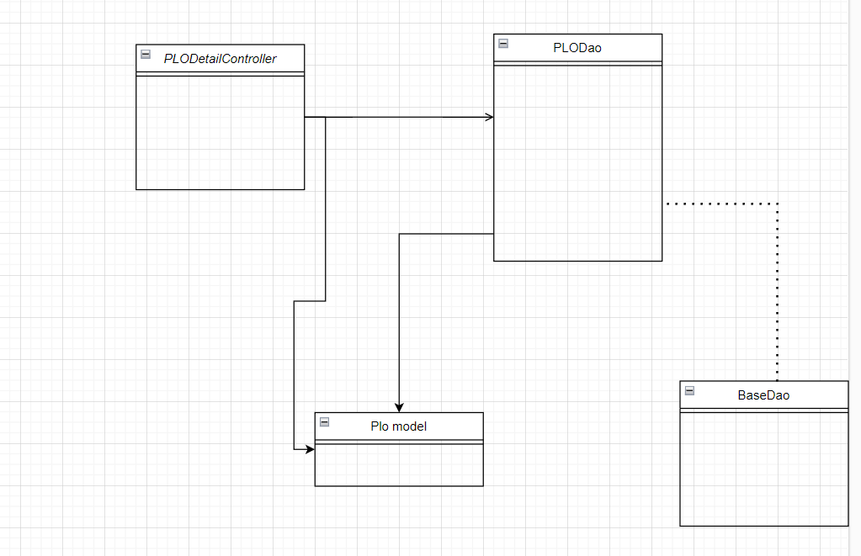

b. Sequence Diagram

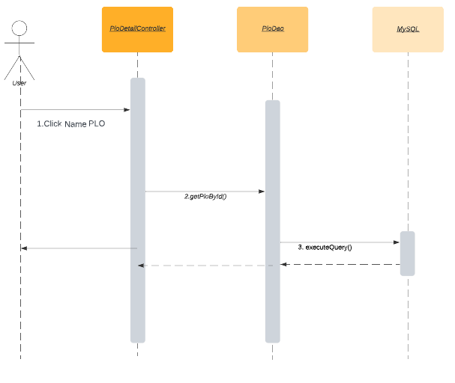

c. Database Queries

SELECT * FROM plo where plo_id = ?

SELECT * FROM Curriculum c INNER JOIN Decision d ON c.decision_id = d.decision_id where curriculum_id = ?

**30. Curriculums Details/PLO Management/PLO-PO Mapping**

a. Class Diagram

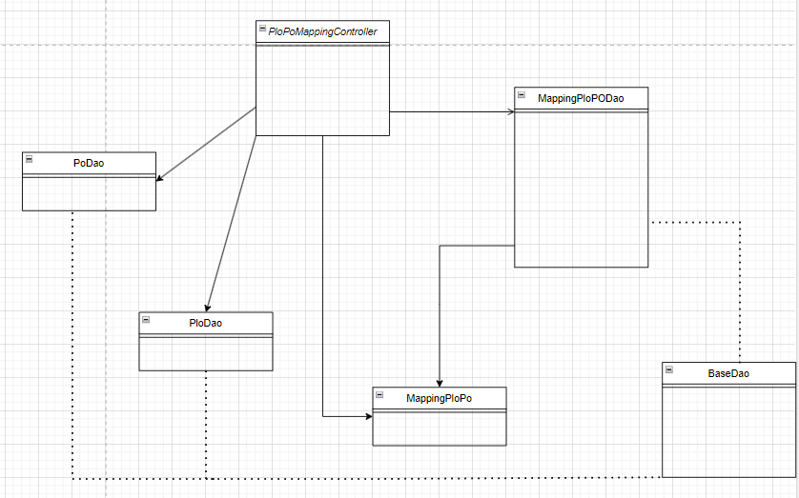

b. Sequence Diagram

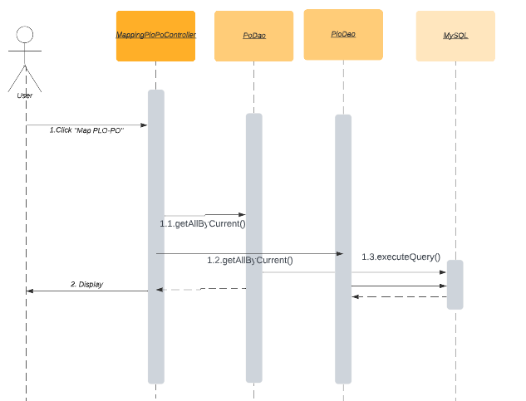

c. Database Queries

SELECT p.po_id, po.plo_id\n" +

" FROM plo po \n" +

" JOIN po_plo pl ON po.plo_id = pl.plo_id\n" +

" Join po p On pl.po_id = p.po_id\n" +

" WHERE po.curriculum_id = ? and p.curriculum_id = ?

SELECT * FROM plo "

+ "where curriculum_id = ?

SELECT * FROM po where curriculum_id = ?

SELECT * FROM Curriculum c INNER JOIN Decision d ON c.decision_id = d.decision_id where curriculum_id = ?

DELETE FROM po_plo\n"

+ "WHERE plo_id = ? AND po_id =?

INSERT INTO po_plo\n"

+ "(`plo_id`, `po_id`)\n"

+ "VALUES (?, ?);

## **31. Curriculums Details/Subject Groups/Combo List**

**a. Class Diagram**

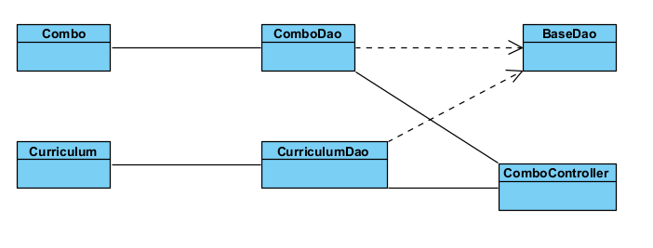

**b. Sequence Diagram**

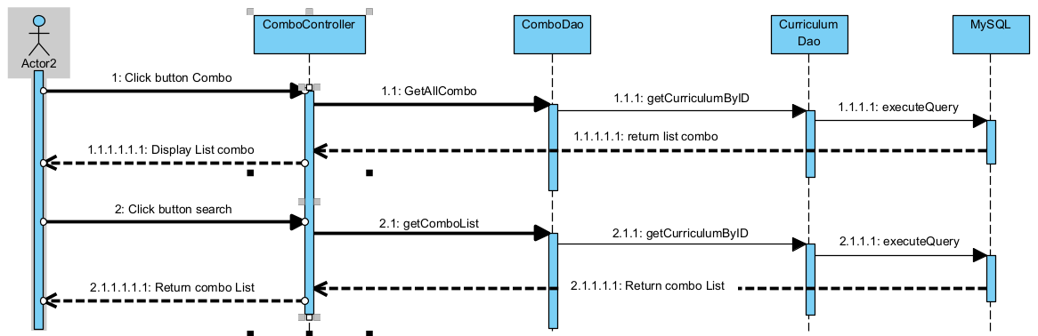

**c. Database Queries**

* **SELECT * FROM Curriculum c INNER JOIN Decision d ON c.decision_id = d.decision_id where curriculum_id = ?**
* **select * from subject_group WHERE curriculum_id = ? AND group_type LIKE 'combo' AND( subject_group_id = ? OR name LIKE ? LIMIT ?,5**
* **select * from subject_group WHERE curriculum_id = ? AND group_type LIKE 'combo'**

## **31.1 Curriculums Details/Subject Groups/New Combo**

**a. Class Diagram**

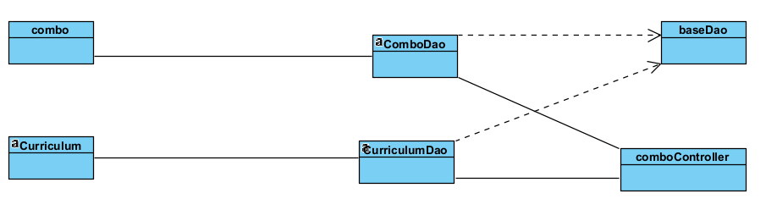

**b. Sequence Diagram**

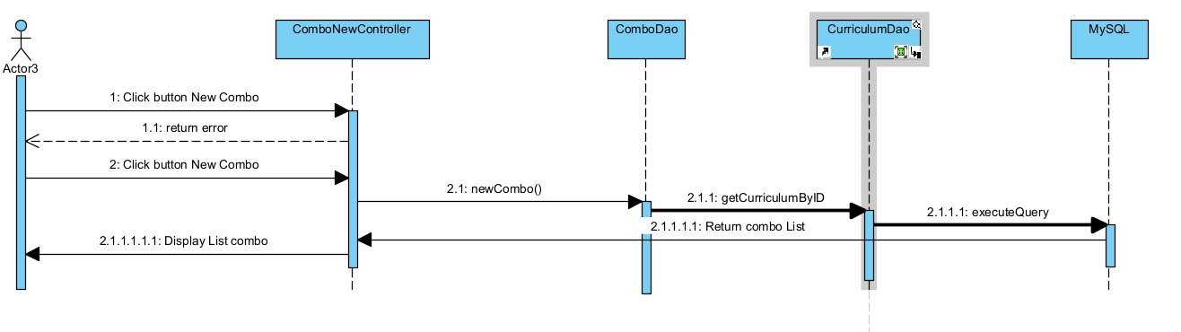

**c. Database Queries**

* **SELECT * FROM decision where decision_no = ?**
* **INSERT INTO g5_flm.decision (decision_no,decision_date,creator_id,is_active,name) VALUES (?, ?, ?, ?, ?)**

## **32. Curriculums Details/Subject Groups/Combo Details**

**a. Class Diagram**

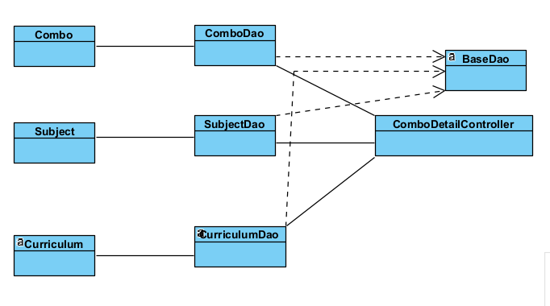

**b. Sequence Diagram**

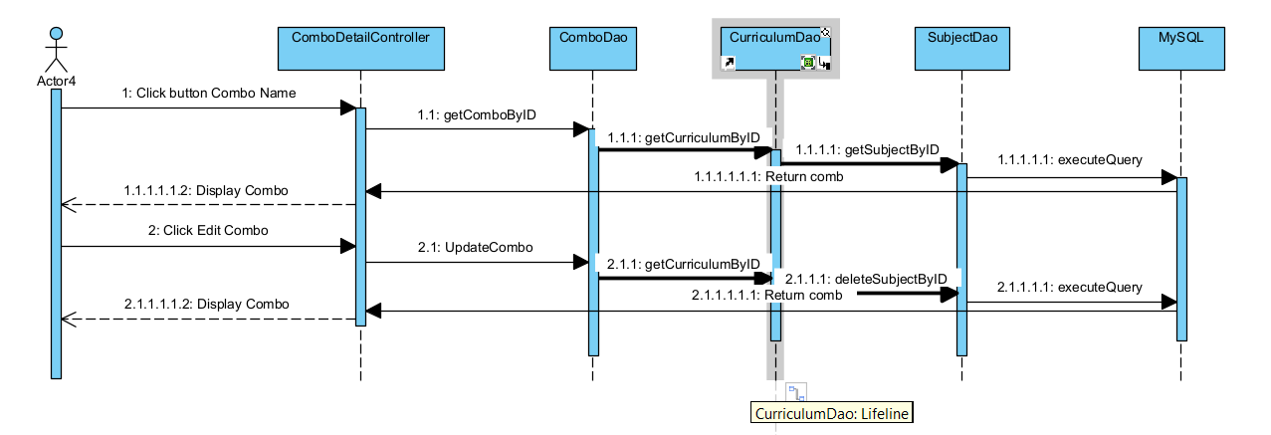

**c. Database Queries**

* **SELECT * FROM Curriculum c INNER JOIN Decision d ON c.decision_id = d.decision_id where curriculum_id = ?**
* **SELECT sub.subject_id, sub.code, sub.name, sub.semester, sub.no_credit , sub.pre_condition FROM subject sub JOIN curriculum_subject cuSub ON sub.subject_id = cuSub.subject_id WHERE cuSub.curriculum_id = ? AND subject_group_id = ?**
* **DELETE FROM `g5_flm`.`curriculum_subject` WHERE subject_group_id = ? AND subject_id = ?**
* **UPDATE `subject_group` SET `group_type` = ?,`name` = ?,`english_name` = ? WHERE `subject_group_id` = ?**

## **33. Curriculums Details/Subject Groups/Content Group List**

**a. Class Diagram**

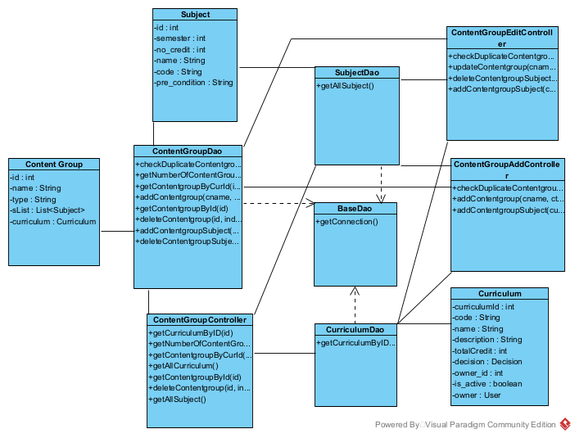

**b. Sequence Diagram**

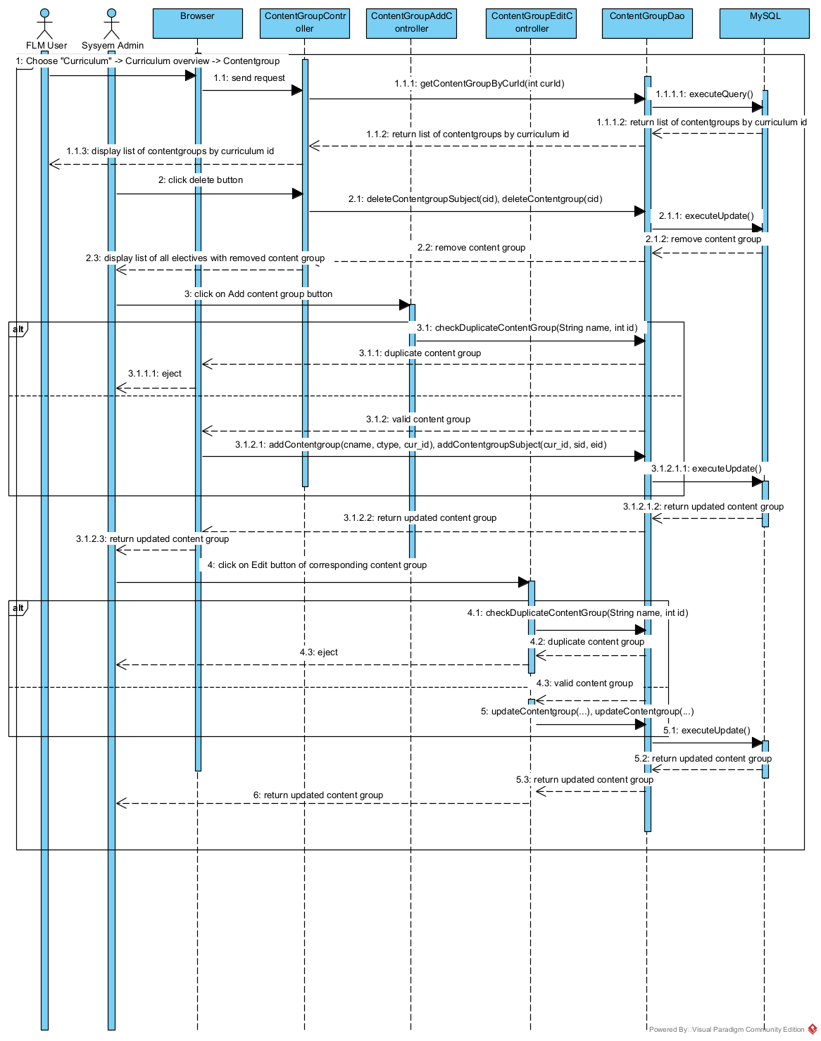

**c. Database Queries**

* update curriculum_subject set curriculum_id = ? where subject_group_id = ?
* delete from curriculum_subject where subject_group_id = ? and curriculum_id = ?
* update subject_group set name = ?, group_type = ?, curriculum_id = ? where subject_group_id = ?
* select * from subject_group where name = ? and subject_group_id != ? and curriculum_id = ?
* select * from subject_group where subject_group_id = ?
* insert into curriculum_subject (curriculum_id, subject_id, subject_group_id) values (?, ?, ?)
* insert into subject_group (curriculum_id, group_type, name) values (?, ?, ?)
* select * from subject_group where name = ? and curriculum_id = ?
* select * from subject_group where curriculum_id = ? limit ?, 5
* select count(*) from subject_group where curriculum_id = ?

## **34. Curriculums Details/Subject Groups/Content Group Details**

**a. Class Diagram**

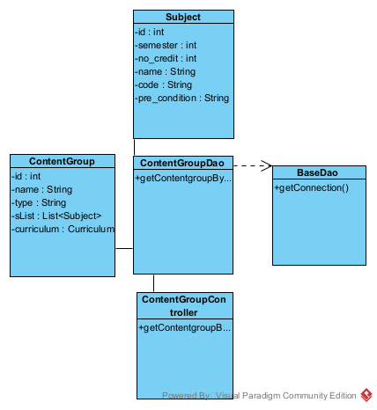**s**

**b. Sequence Diagram**

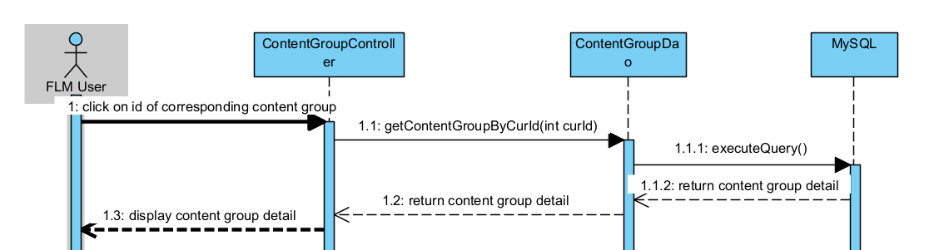

**c. Database Queries**

* select * from subject_group where subject_group_id = ?

## **35. Curriculums Details/Subject Groups/Elective List**

**a. Class Diagram**

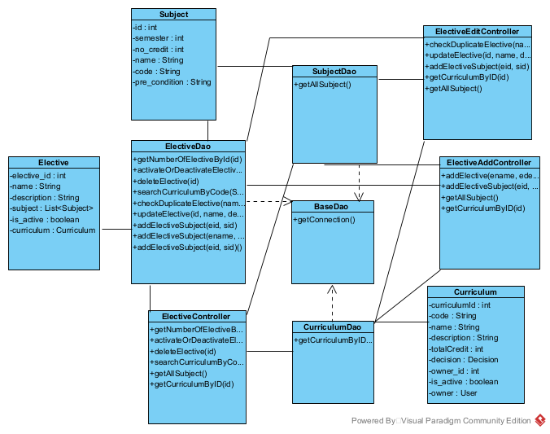

**b. Sequence Diagram**

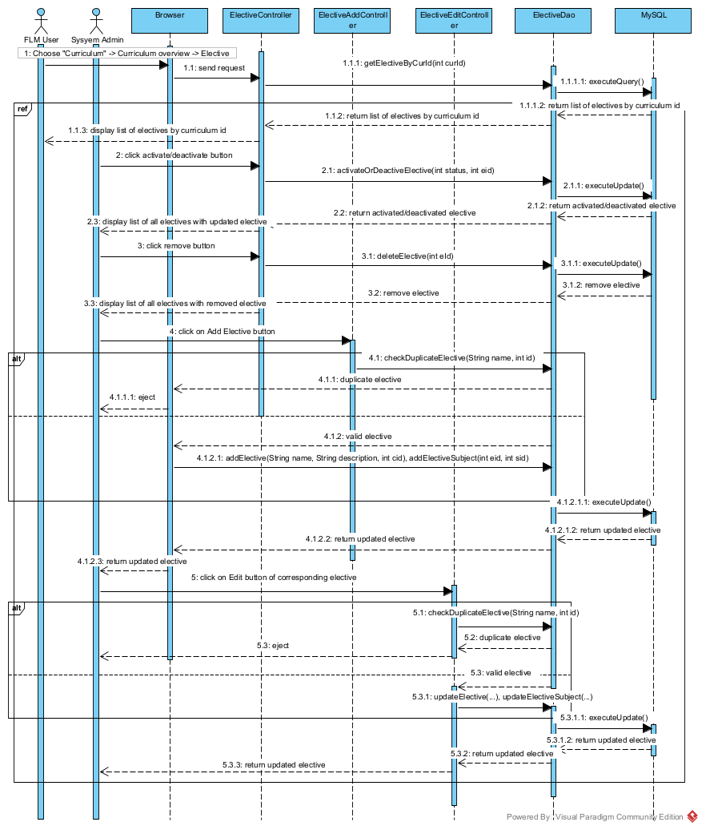

**c. Database Queries**

* select elective.* from elective join elective_subject on elective.elective_id = elective_subject.elective_id join subject on subject.subject_id = elective_subject.subject_id where elective.name like ? or code like ?;
* select * from elective where curriculum_id = ? limit ?, 5
* select count(*) from elective where curriculum_id = ?
* update elective set is_active = ? where elective_id = ?
* insert into elective (name, description, is_active, curriculum_id) values (?, ?, 1, ?)
* insert into elective_subject values (?, ?)
* delete from elective where elective_id = ?
* select subject.* from elective join elective_subject on elective.elective_id = elective_subject.elective_id join subject on subject.subject_id = elective_subject.subject_id where elective_subject.elective_id = ?
* select * from elective where name = ? and curriculum_id = ? and elective_id != ?
* update elective set name = ?, description = ?, is_active = ? where elective_id = ?
* delete from elective_subject where elective_id = ?
* select * from elective where elective_id = ?

## **35. Curriculums Details/Subject Groups/Elective Details**

**a. Class Diagram**

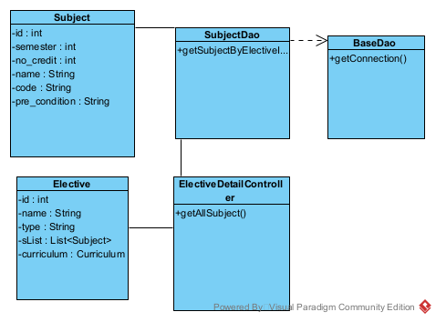

**b. Sequence Diagram**

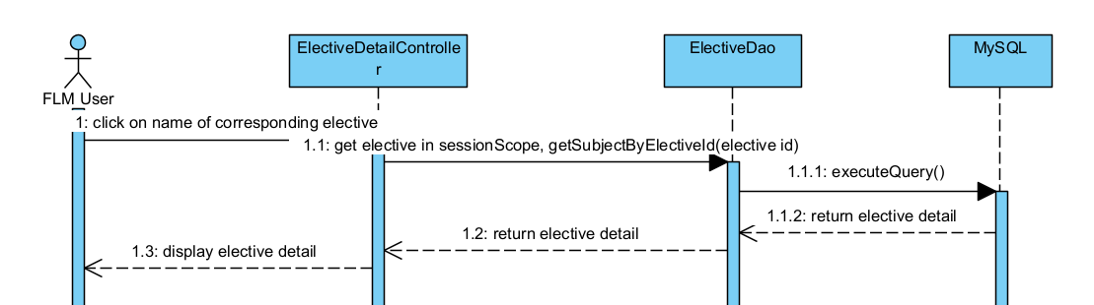

**c. Database Queries**

* select subject.* from elective join elective_subject on elective.elective_id elective_subject.elective_id join subject on subject.subject_id elective_subject.subject_id where elective_subject.elective_id = ?;

## **37. Syllabus Management/Syllabus Management/Syllabus List**

**a. Class Diagram**

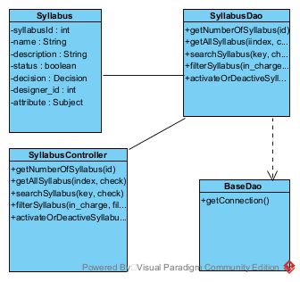

**b. Sequence Diagram**

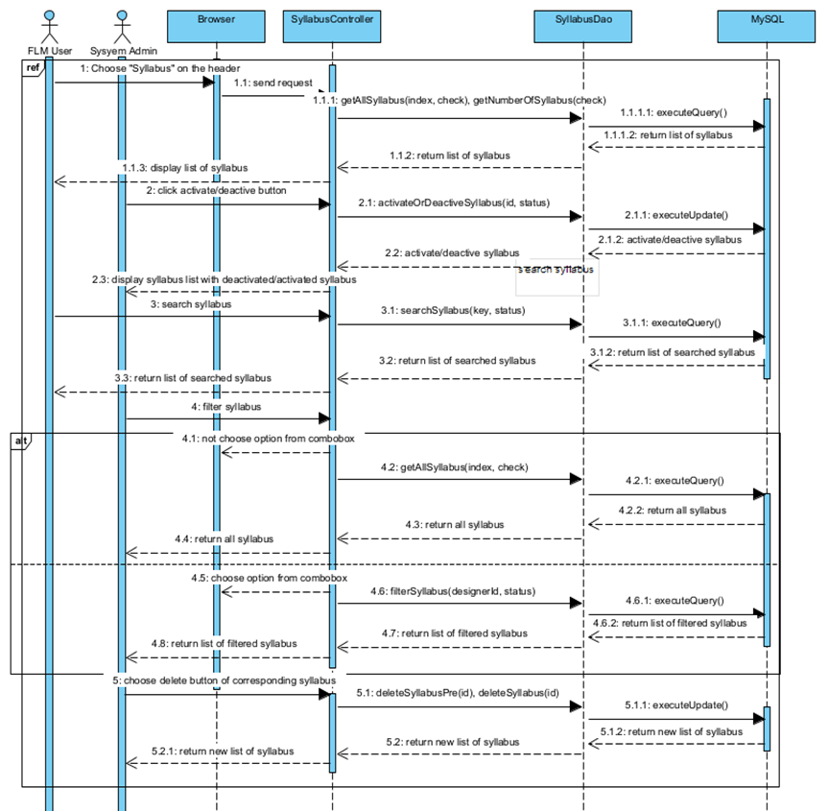

**c. Database Queries**

* select count(*) from syllabus where syllabus.is_active = 1
* select syllabus.*, decision_no, decision_date from syllabus left join decision on syllabus.decision_id = decision.decision_id where syllabus.is_active = 1 limit ?, 8
* select * from syllabus where designer_id = ? and is_active = ?
* select * from syllabus where name like ? or description like ? or syllabus_id = ? and is_active = 1
* update syllabus set is_active = ? where syllabus_id = ?
* delete from pre_requisite where syllabus_id = ?
* delete from syllabus where syllabus_id = ?

## **38. Syllabus Management/Syllabus Management/New Syllabus**

**a. Class Diagram**

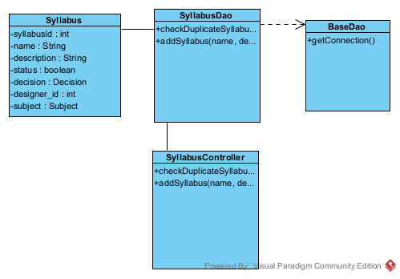

**b. Sequence Diagram**

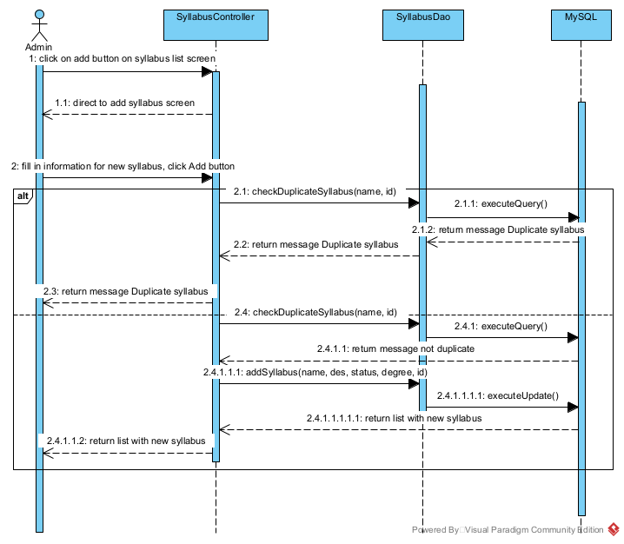

**c. Database Queries**

* select * from syllabus where name = ? and syllabus_id != ?
* insert into syllabus(name, description, is_active, degree_level, designer_id) values (?, ?, ?, ?, ?)

## **39. Syllabus Management/Syllabus Management/Syllabus Import**

**a. Class Diagram**

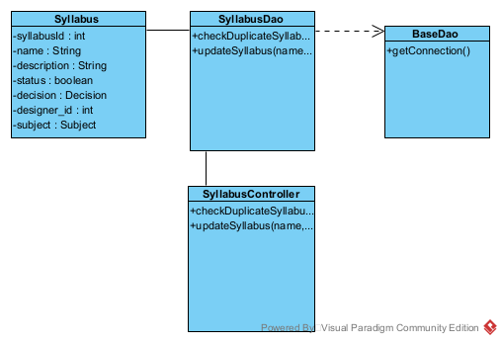

**b. Sequence Diagram**

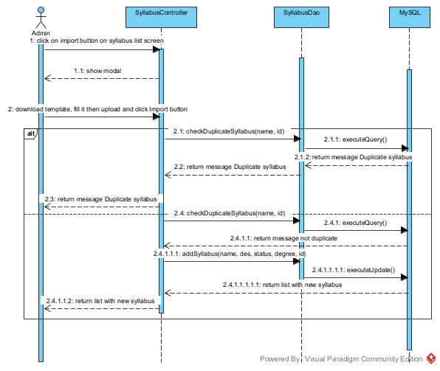

**c. Database Queries**

* select * from syllabus where name = ? and syllabus_id != ?
* update syllabus set name = ?, description = ?, is_active = ?, degree_level = ? where syllabus_id = ?

## **40. Syllabus Management/Syllabus Management/Syllabus Overview**

**a. Class Diagram**

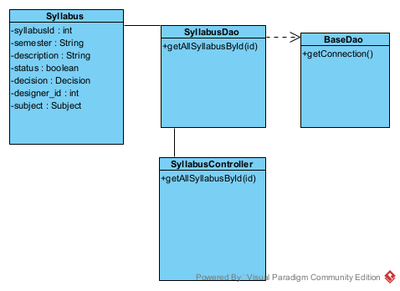

**b. Sequence Diagram**

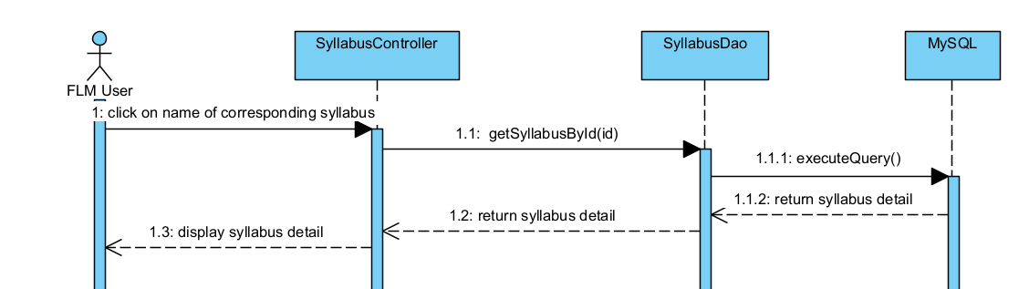

**c. Database Queries**

* select * from syllabus where syllabus_id = ?

## **41. Syllabus Management/Syllabus Management/Syllabus Edit**

**a. Class Diagram**

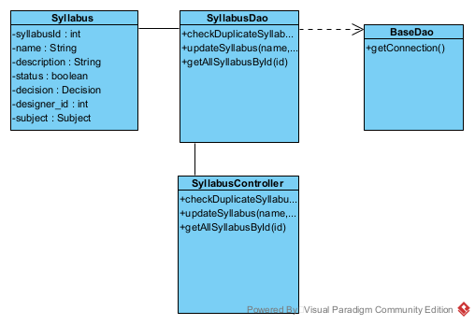

**b. Sequence Diagram**

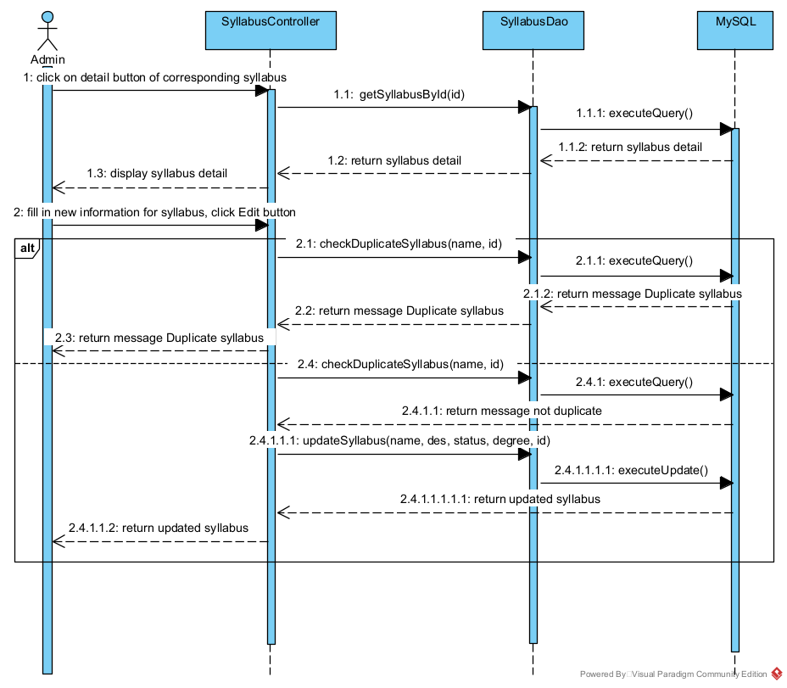

**c. Database Queries**

* select * from syllabus where syllabus_id = ?
* select * from syllabus where name = ? and syllabus_id != ?
* update syllabus set name = ?, description = ?, is_active = ?, degree_level = ? where syllabus_id = ?

## 42. Syllabus Management/CLO Management/CLO List

### a. Class Diagram

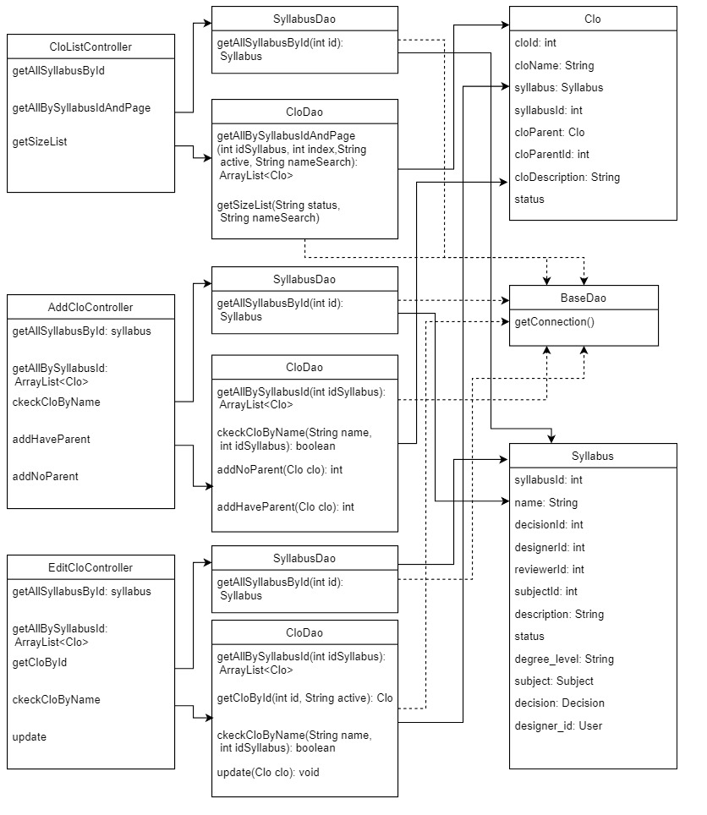

### b. Sequence Diagram

b.1/ CLO List

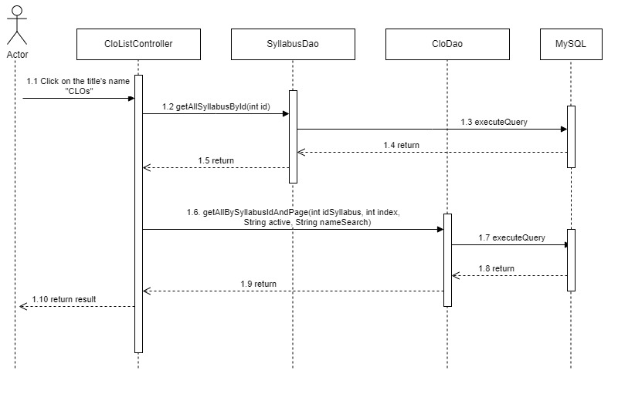

b.2/ Add CLO

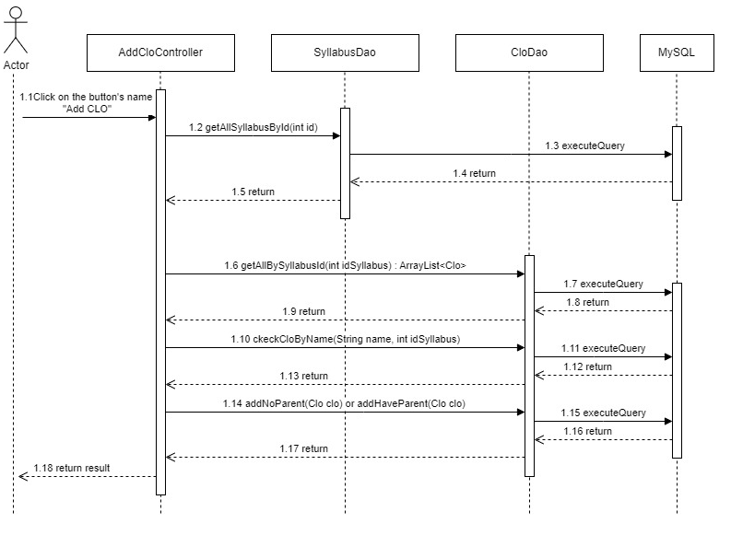

b.3/ Edit CLO

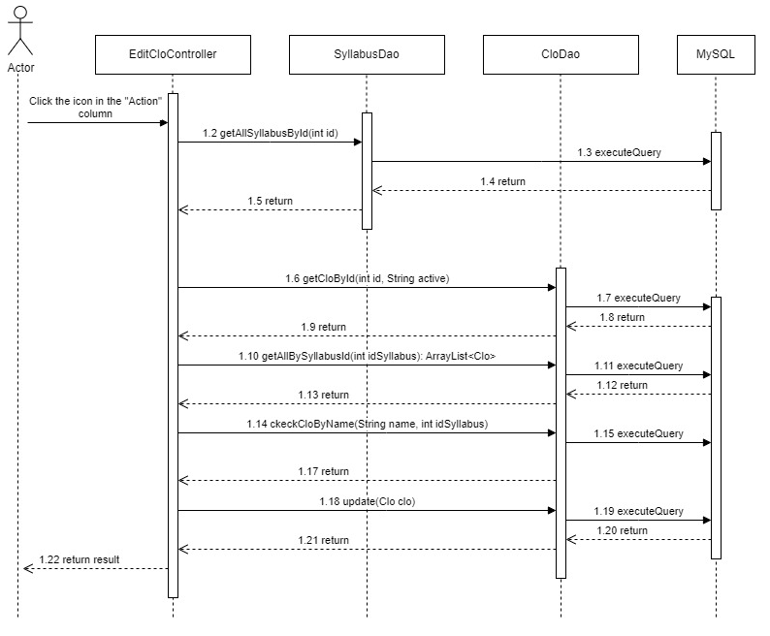

### c. Database Queries

* SELECT * from syllabus where syllabus_id = ?
* SELECT count(*) as co FROM clo WHERE status like ? AND name like ?
* SELECT * FROM clo WHERE syllabus_id = ? AND status like ? AND name like ? limit ?,?
* SELECT * FROM clo WHERE syllabus_id = ?
* SELECT * FROM clo WHERE name = ? AND syllabus_id = ?
* INSERT INTO `clo` (`name`,`syllabus_id`,`description`) VALUES (?, ?, ?);
* INSERT INTO `clo` (`name`,`syllabus_id`,`parent_lo_id`,`description`) VALUES (?, ?, ?, ?);
* UPDATE `clo` SET `name` = ?, `syllabus_id` = ?, `parent_lo_id` = "+idParent+", `description` = ? WHERE `clo_id` = ?

## **43. Syllabus Management/CLO Management/CLO Details**

### a. Class Diagram

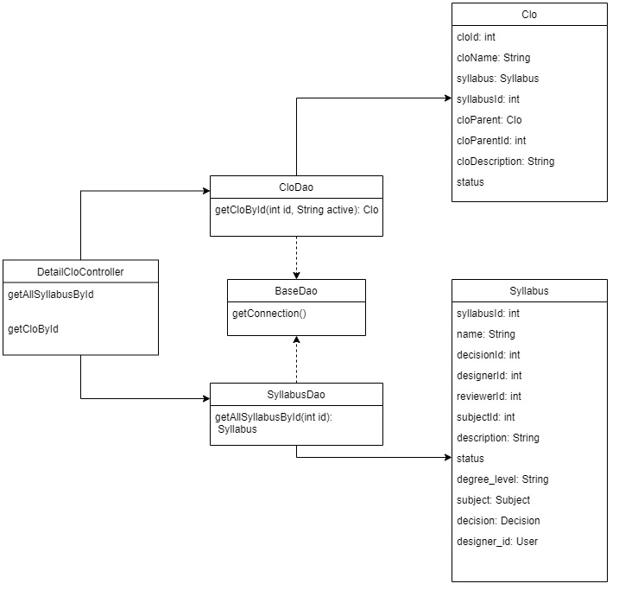

### b. Sequence Diagram

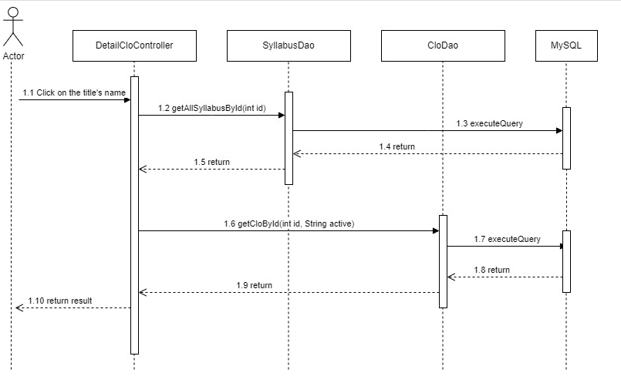

### c. Database Queries

* SELECT * FROM clo WHERE clo_id = ? AND status like ?
* select * from syllabus where syllabus_id = ?

## 44. Syllabus Management/CLO Management/CLO Import

### a. Class Diagram

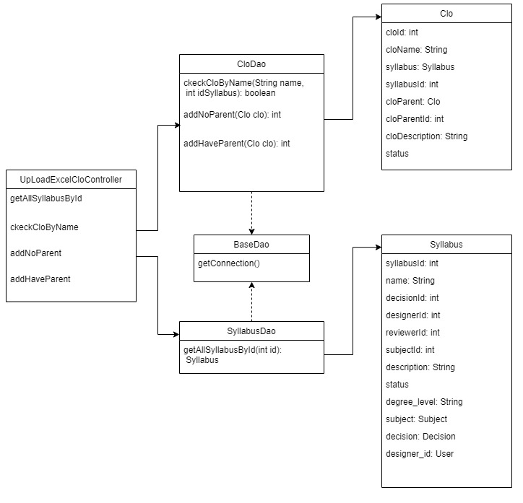

### b. Sequence Diagram

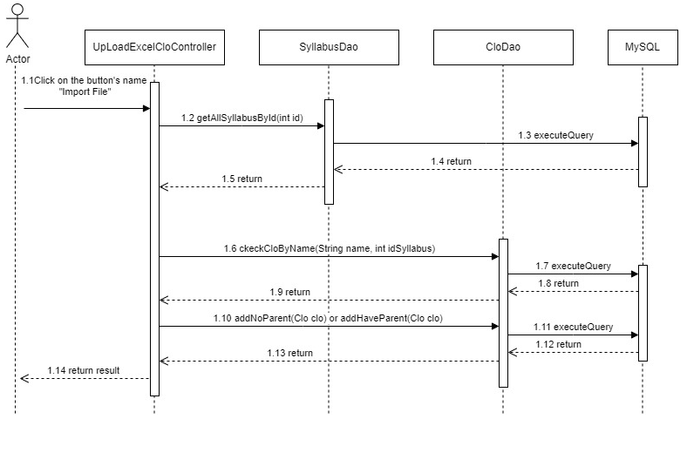

### c. Database Querie

* SELECT * from syllabus where syllabus_id = ?
* SELECT * FROM clo WHERE clo_id = ? AND status like ?
* SELECT * from syllabus where syllabus_id = ?
* SELECT * FROM clo WHERE name = ? AND syllabus_id = ?

## 45. Syllabus Management/Session Management/Session List

**a. Class Diagram**

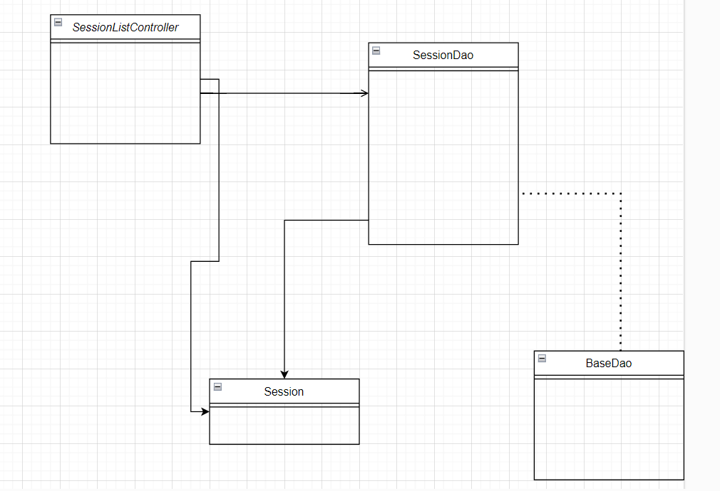

**b. Sequence Diagram**

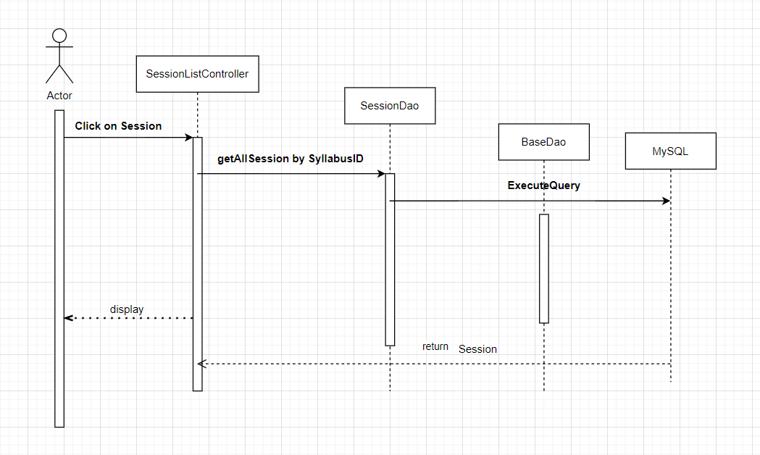

**c. Database Queries**

SELECT * FROM session \n"

+ " where syllabus_id = ? AND session_id LIKE ? " + "limit ?,3

## 59. Decision Management/Syllabus Submits/Decision List

**a. Class Diagram**

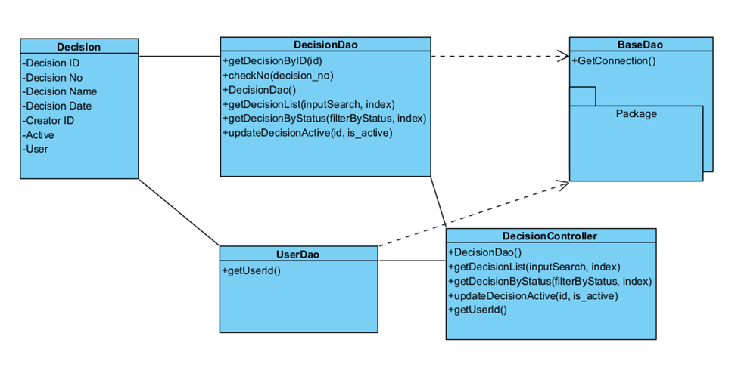

**b. Sequence Diagram**

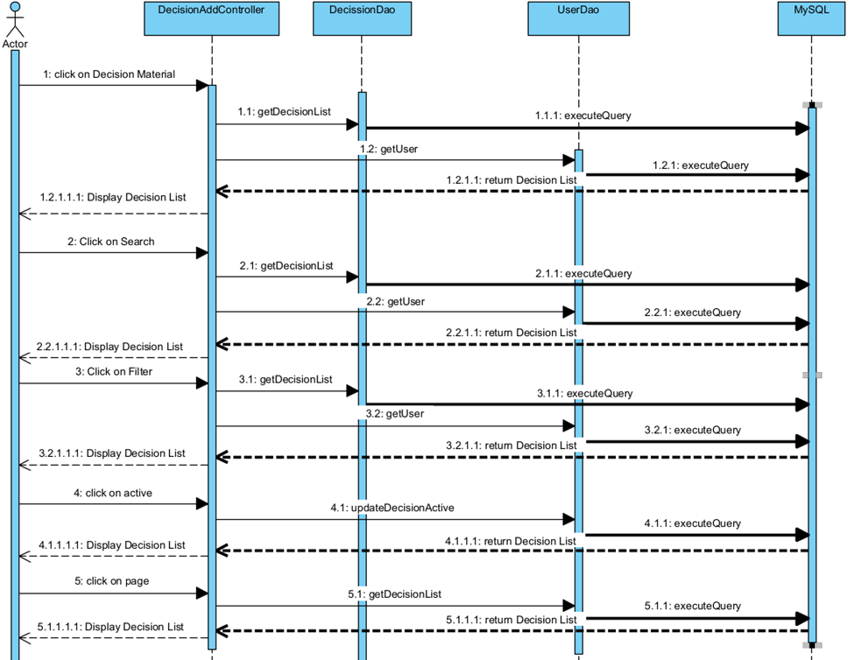

**c. Database Queries**

-SELECT * FROM g5_flm.decision WHERE decision_no LIKE ? OR decision_id = ? LIMIT ?,5

-SELECT * FROM g5_flm.decision WHERE is_active = ? LIMIT ?,5

-UPDATE g5_flm.decision SET is_active = ? WHERE decision_id = ?

select * from user where user_id = ?

## 60. Decision Management/Syllabus Submits/Decision Details

**a. Class Diagram**

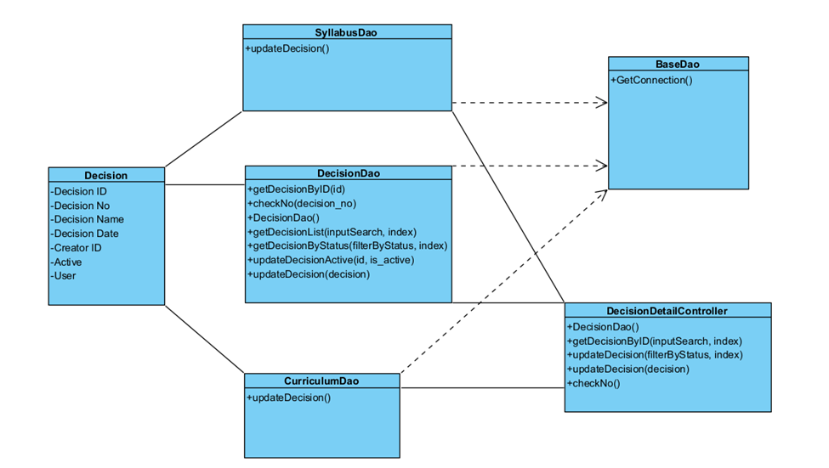

**b. Sequence Diagram**

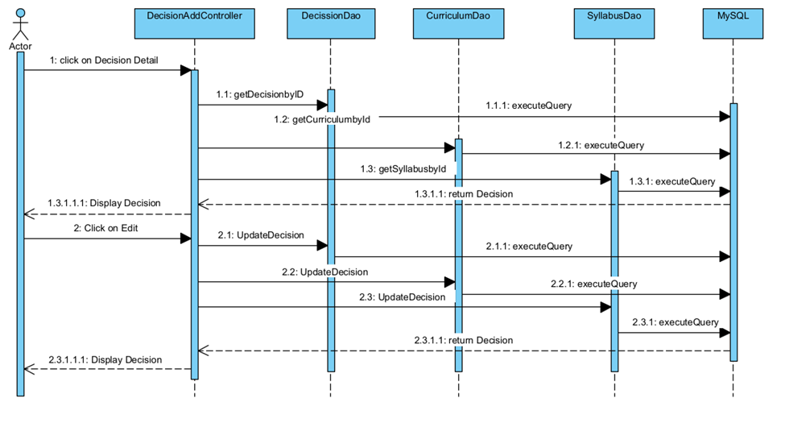

**c. Database Queries**

**SELECT * FROM decision where decision_no = ?**

**select * from user where user_id = ?**

UPDATE g5_flm.decision SET decision_no = ?, name = ?, decision_date = ?, is_active = ? WHERE decision_id = ?

SELECT * FROM g5_flm.curriculum WHERE decision_id = ?

SELECT * FROM g5_flm.syllabus WHERE decision_id = ?

SELECT * FROM g5_flm.decision WHERE decision_id = ?

UPDATE g5_flm.curriculum SET decision_id = null WHERE curriculum_id = ?

UPDATE g5_flm.syllabus SET decision_id = null WHERE syllabus_id = ?

## 61. Decision Management/Syllabus Submits/New Decision

**a. Class Diagram**

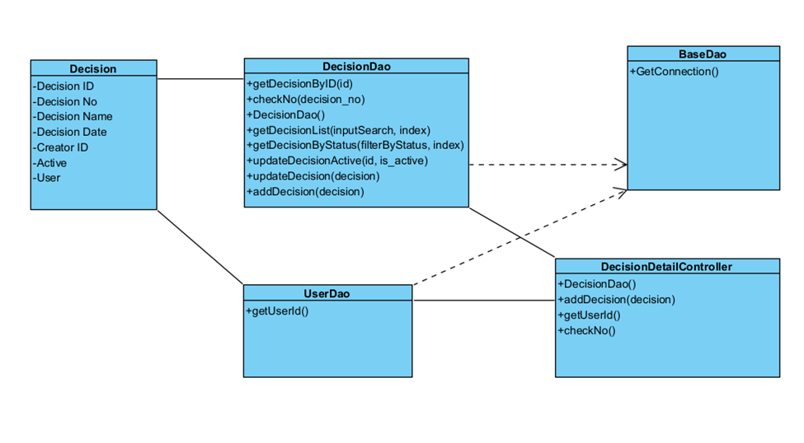

**b. Sequence Diagram**

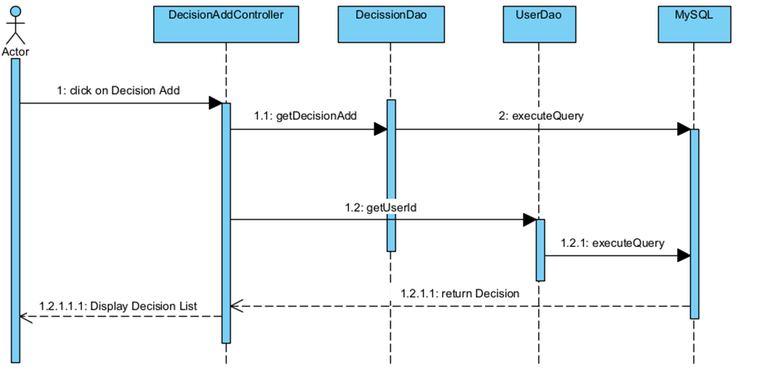

**c. Database Queries**

SELECT * FROM decision where decision_no = ?

select * from user where user_id = ?

INSERT INTO g5_flm.decision decision_no,decision_date, creator_id, is_active,name) VALUES (?, ?, ?, ?)

## 62. Decision Management/Syllabus Submits/Decision Overview

**a. Class Diagram**

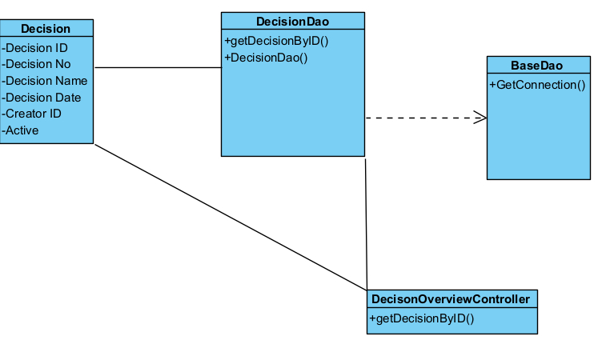

**b. Sequence Diagram**

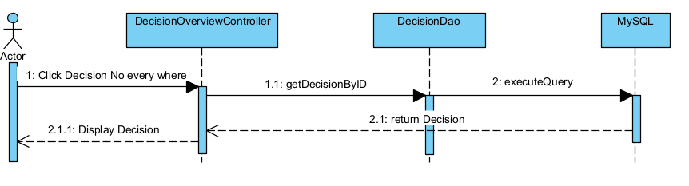

**c. Database Queries**

* select * from decision where decision_id = ?